

Project Report - Manual Exercises (Bac +2)
LAB 06

Submitted by: ALAGO CHIEMELA VICTOR
KHANH NGUYEN TRAN
DUC-TIN NGUYEN
Date submitted: 5th May 2024.

Completed in partial fulfillment of the requirements for the course:
CLOUD COMPUTING
At:
EPITA, SCHOOL OF ENGINEERING AND COMPUTER SCIENCE
Academic Year: 2023/2024
Paris, 12th April 2024.

INTRODUCTION:
In today's tech world, it's really important for software tools and cloud services to work well together to help build and deliver software easily. In this report, we look at how GitLab, a tool that helps developers manage their software projects, works together with Amazon Web Services (AWS), which is a system that provides online space and services for businesses. AWS is known for offering a wide range of online services like computing power and data storage, which are essential for running modern apps and websites.

GitLab helps simplify the job of developers by combining several necessary tools into one platform. This makes it easier to handle software projects from start to finish. By using GitLab with AWS, teams can make their workflow simpler and more effective, which means they can do more in less time. In our lab, we focus on how GitLab can be used with different AWS services like Lambda, Fargate, EKS, ECS, and EC2. Each of these services has its own special role in helping to deploy and manage applications more effectively.

In this report, we will explain how we set up and used GitLab with AWS and talk about the benefits of combining these two. We want to show how this setup helps teams speed up their work and use the full power of the cloud to bring new ideas to life quickly and efficiently.

PART 1: GITLAB + LAMBDA
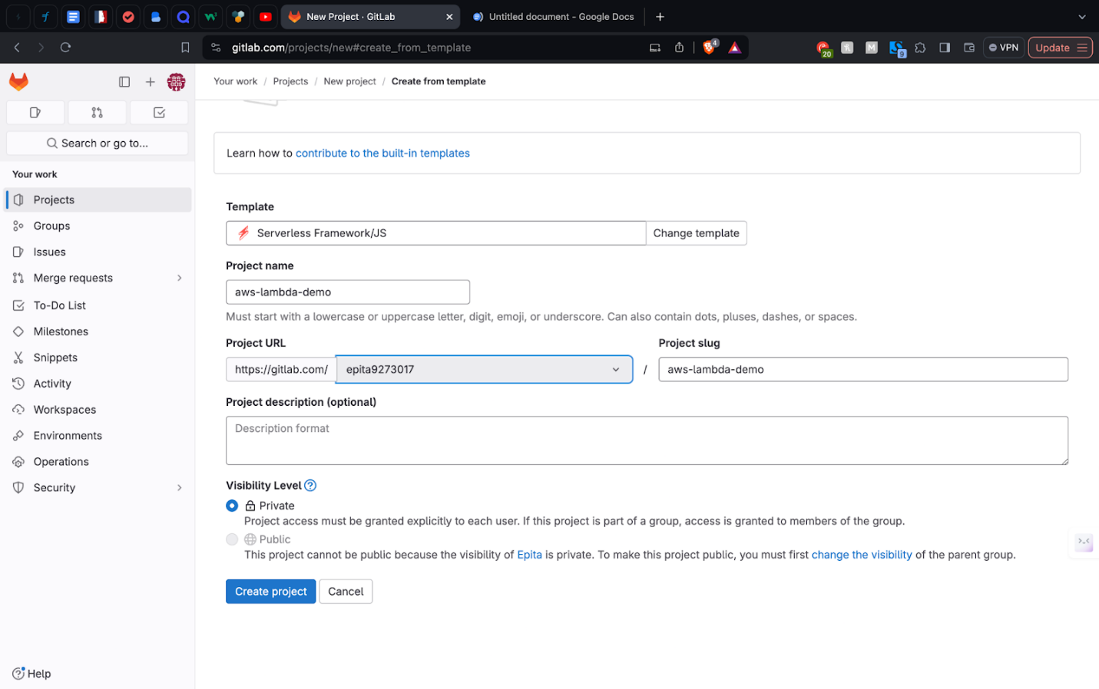
  - Create serverless framework in Gitlab.
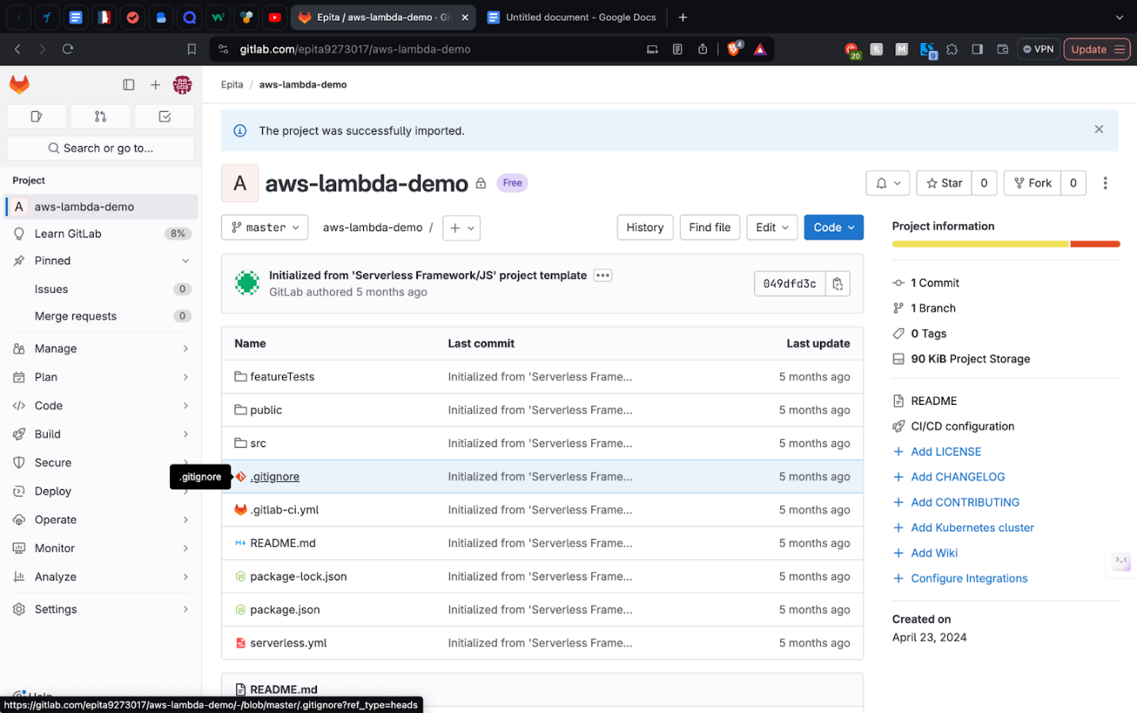
  - Serverless Framework Created

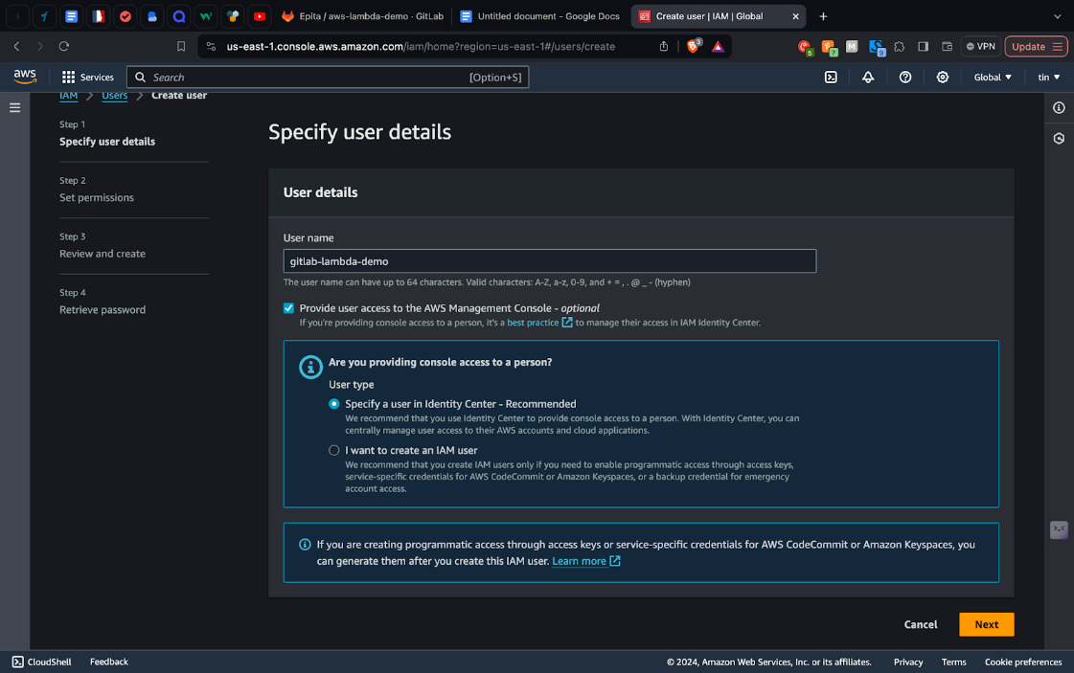

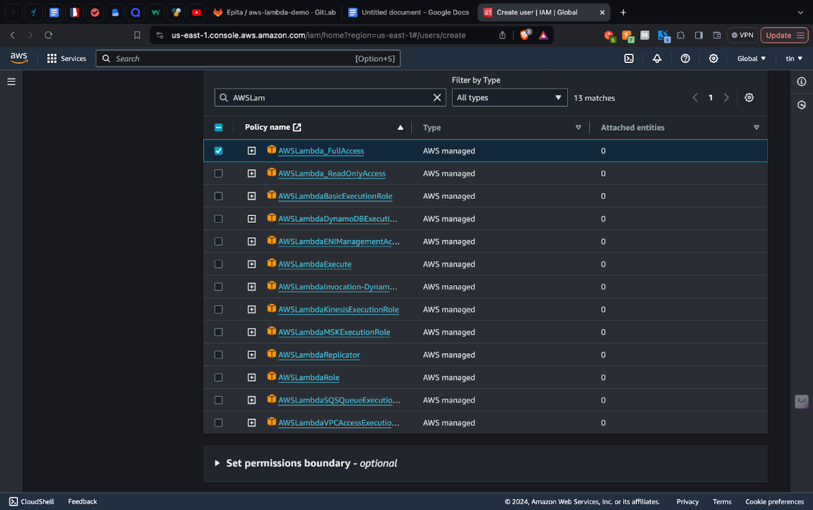
  - Set user detail

  - Set user permissions

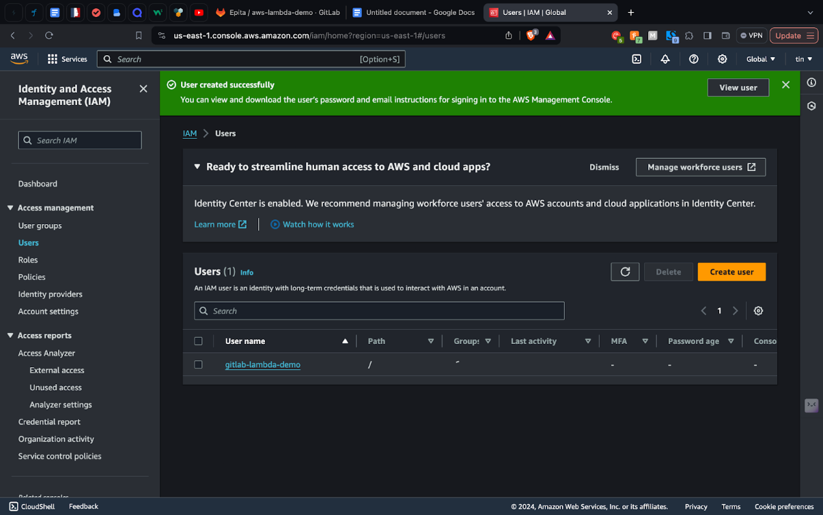
  - User created successfully
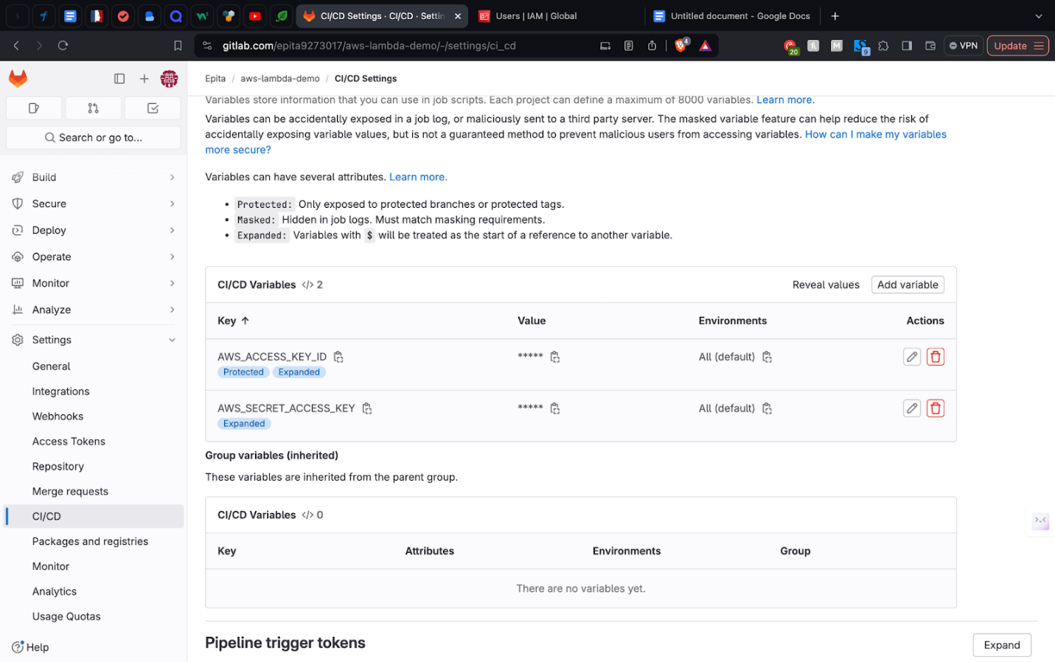
  - Assign AWS credentials to CI/CD Variables
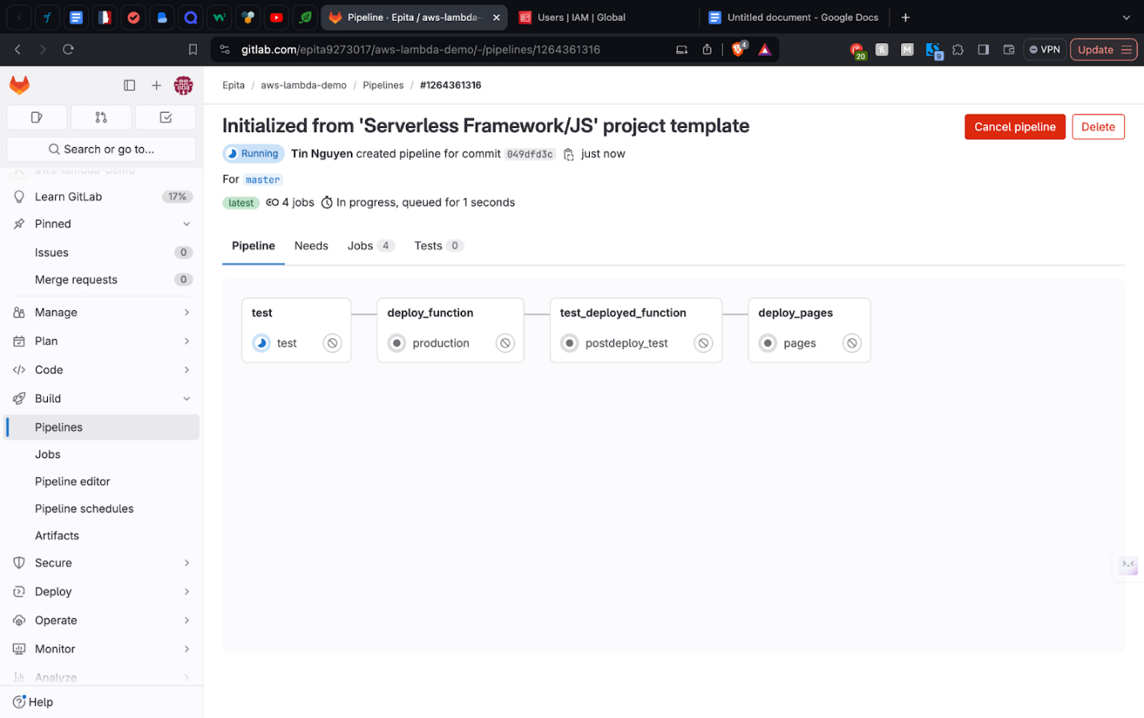
  - Run project pipeline
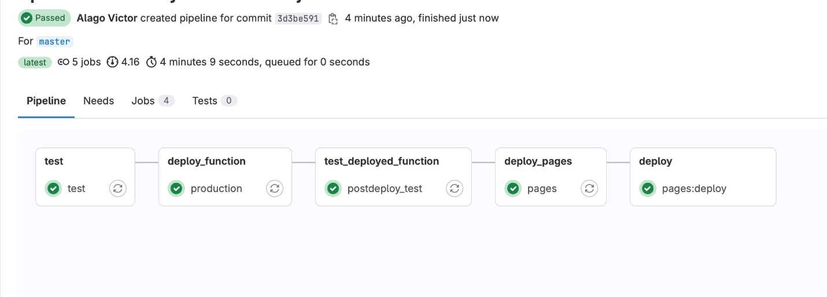
  - All pipeline jobs completed successfully

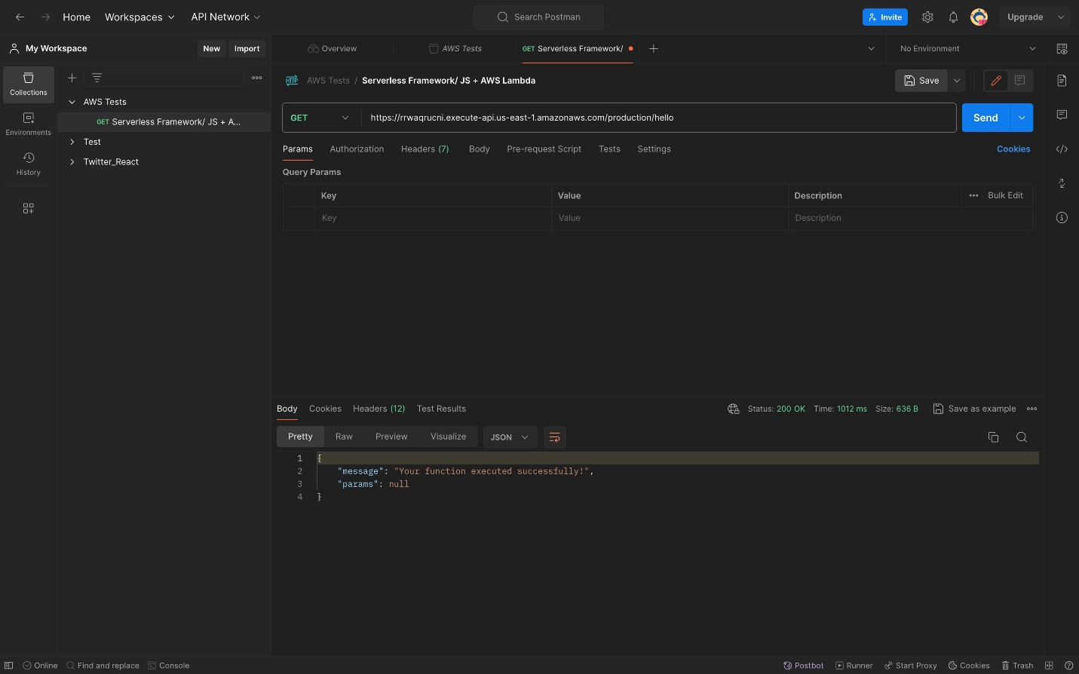
  - Lambda endpoint success

Task 1 Summary

The "GitLab + Lambda" section of our lab focused on how GitLab can be used to efficiently manage and deploy serverless applications using AWS Lambda. AWS Lambda is a service that allows you to run code without worrying about servers, which means you only manage the code and AWS takes care of the rest. This is great for projects where you want to run small pieces of code based on specific actions or events.

In our lab, we explored using GitLab to automate the deployment of Lambda functions. GitLab’s CI/CD pipelines automate the steps needed to get your code from development into production. We used GitLab’s integration tools to easily set up AWS Lambda deployments. This includes creating and updating Lambda functions directly from GitLab, making the whole process simpler and faster.

By integrating GitLab with AWS Lambda, we demonstrated how developers can focus more on writing code and less on the maintenance of servers and infrastructure. This combination proves to be powerful in building efficient, scalable, and cost-effective serverless applications.

PART 2: GITLAB + SAM
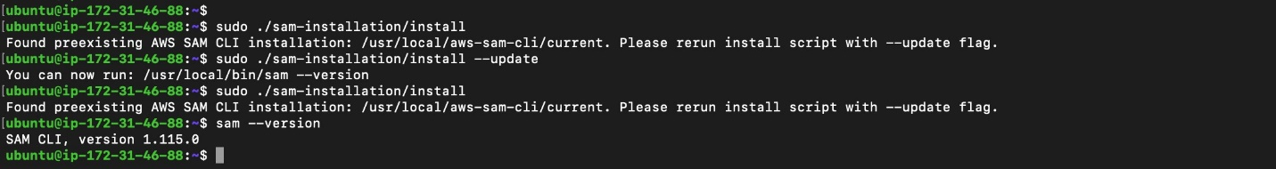
2.1. SAM CLI installed in EC2 UBUNTU
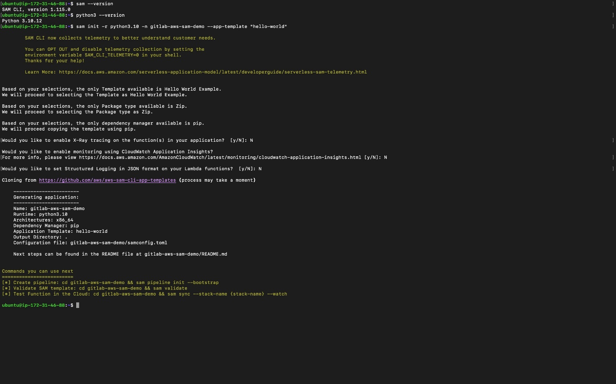
2.2. Generation AWS SAM project

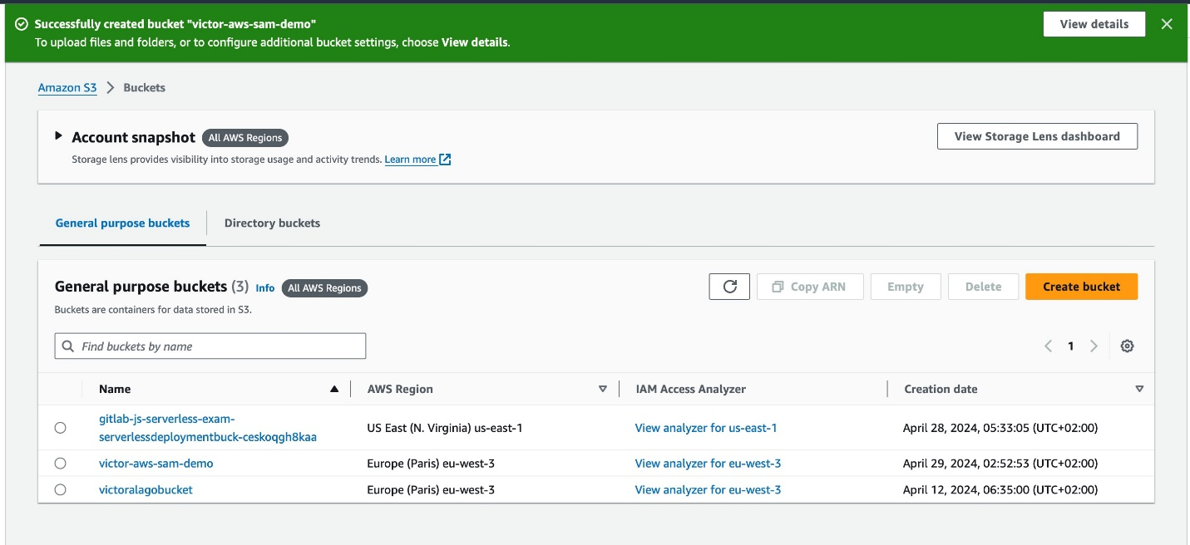
2.3. Create new bucket for the demo
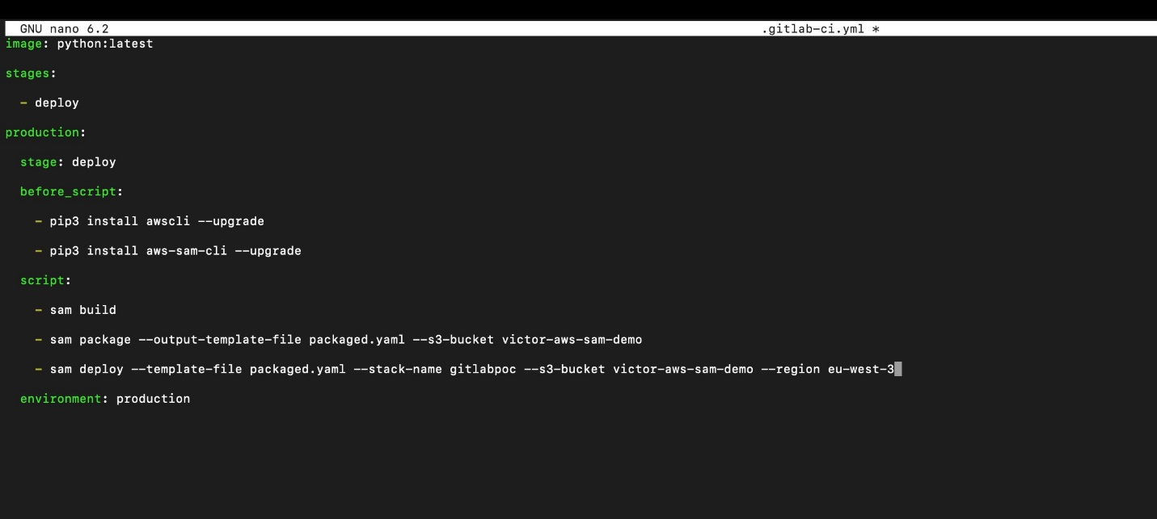
2.4. Gitlab CI file created

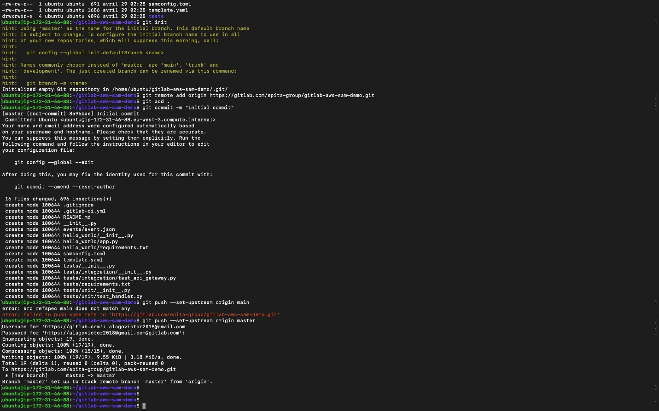
2.5. AWS-SAM-DEMO added to gitlab repo 1
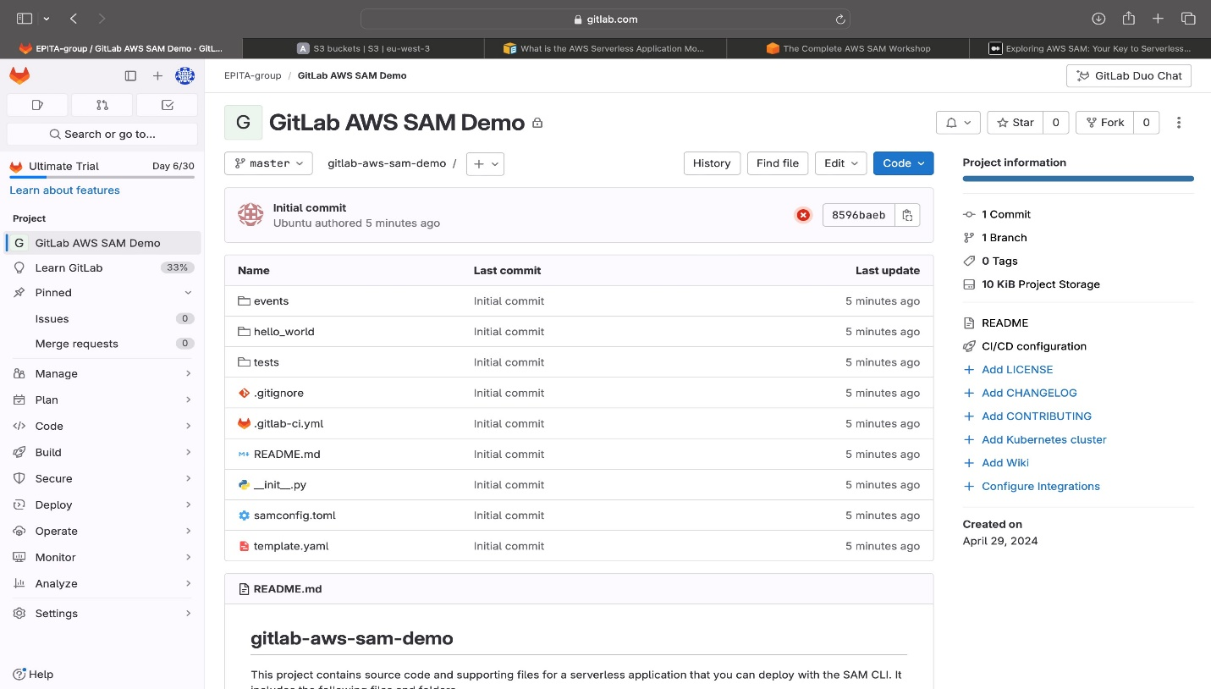
2.6. AWS-SAM-DEMO added to gitlab repo 2
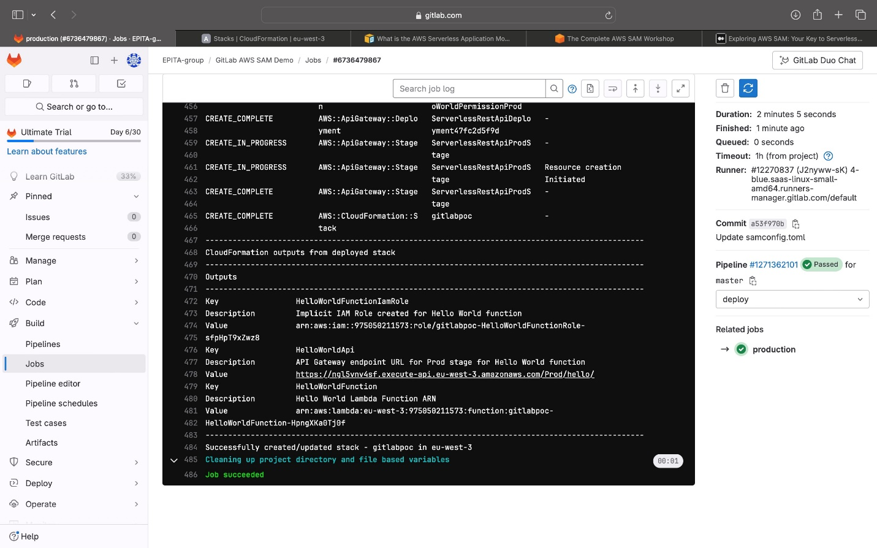
2.7. Production test completed successfully
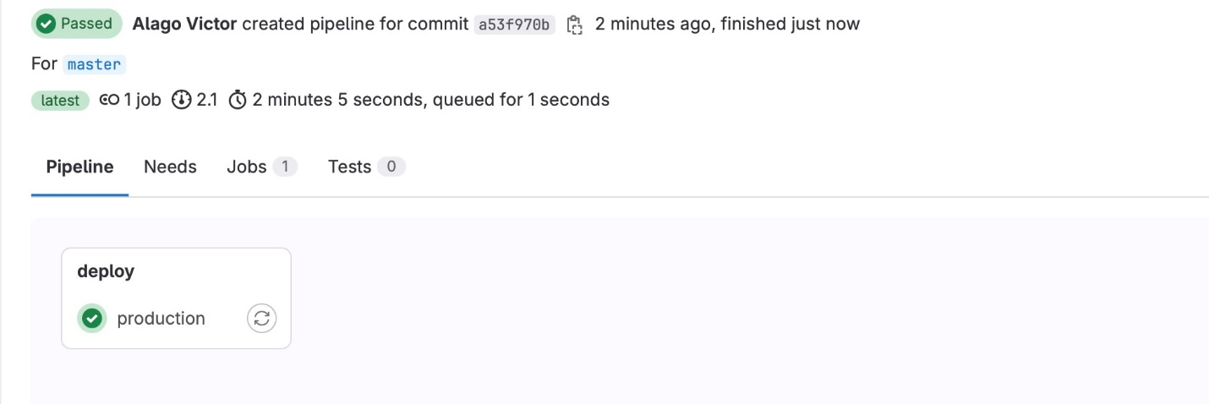
2.8. Production test completed successfully 2

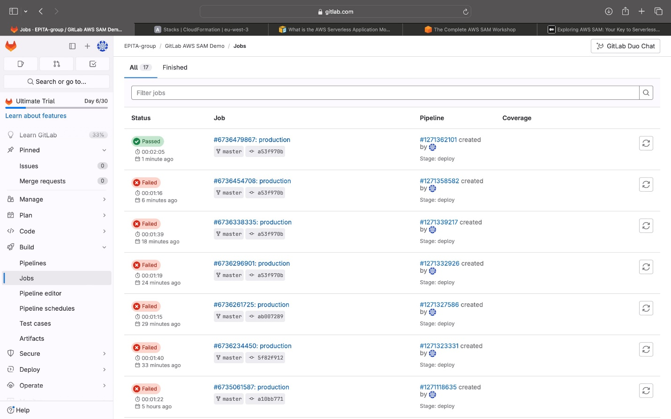
2.9. Production test completed successfully 3.
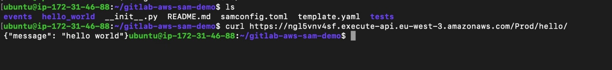
2.10. Curl and URL was successful.

Task 2 Summary
The "GitLab + SAM" section of our lab highlights how GitLab works in conjunction with the AWS Serverless Application Model (SAM), a framework designed to simplify the deployment and management of serverless applications on AWS. AWS SAM extends AWS CloudFormation to provide a simplified syntax for defining the resources your serverless application needs, like Lambda functions and API Gateway APIs.

In this part of the lab, we utilized GitLab's continuous integration and deployment (CI/CD) capabilities to automate the deployment process of a serverless application defined using AWS SAM. We went through setting up a project using a predefined template from the Serverless Framework, integrating it with GitLab, and then managing deployments directly through GitLab pipelines.

This setup not only streamlined the deployment process but also offered a cohesive experience from coding to deployment. By integrating AWS SAM with GitLab, we demonstrated an efficient workflow that allows for the quick and reliable rollout of serverless applications, enabling developers to focus more on development and innovation rather than managing deployments and infrastructure. This shows how powerful and seamless serverless application development can be when using GitLab alongside AWS SAM.

PART 3: GITLAB + FARGATE
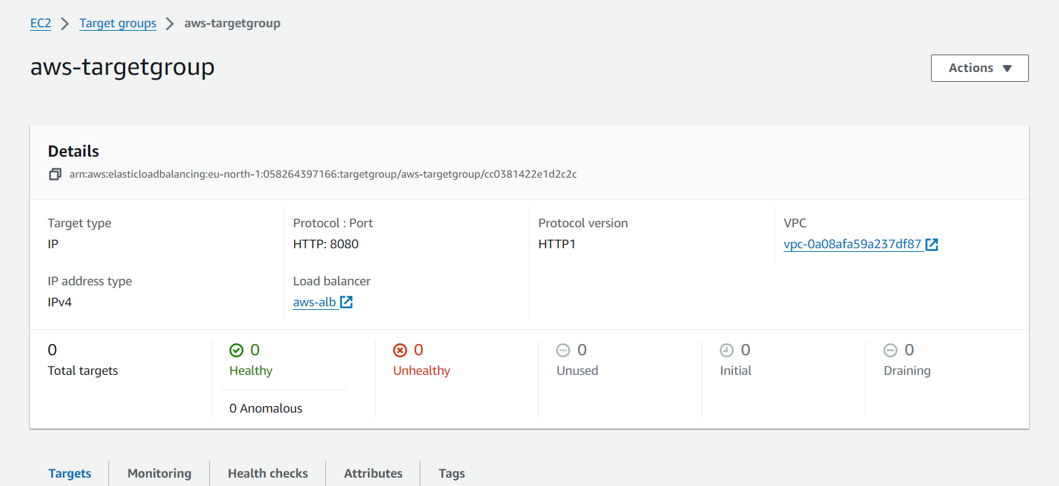
3.1. Create an EC2 target group
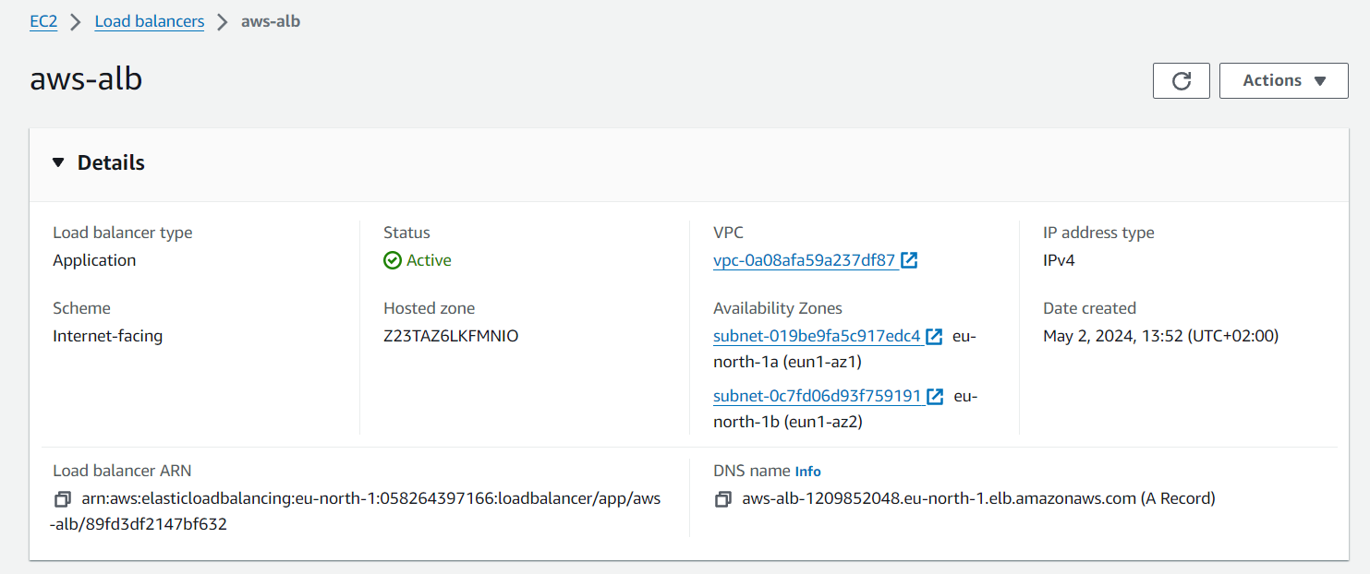
3.2. Create an EC2 load balancer
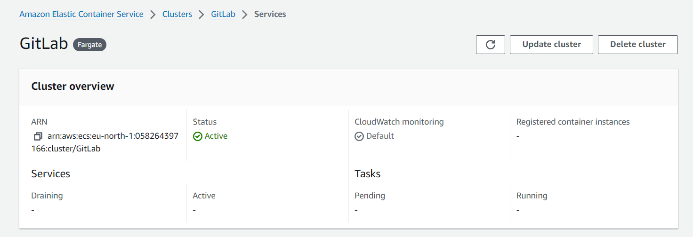
3.3. Create ECS Cluster
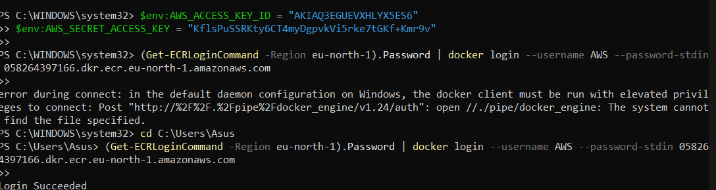
3.4. Login to Docker services
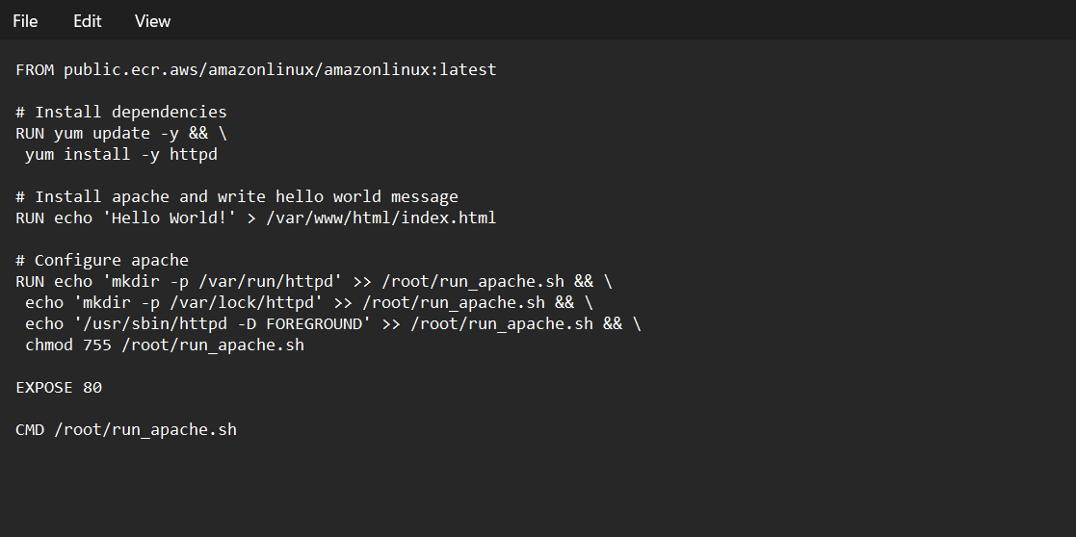
3.5. Create a Dockerfile

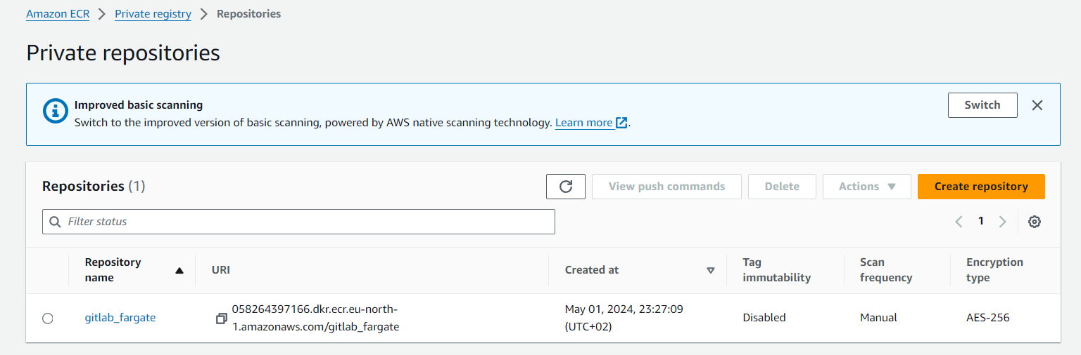
3.6. Create a Private Repositories
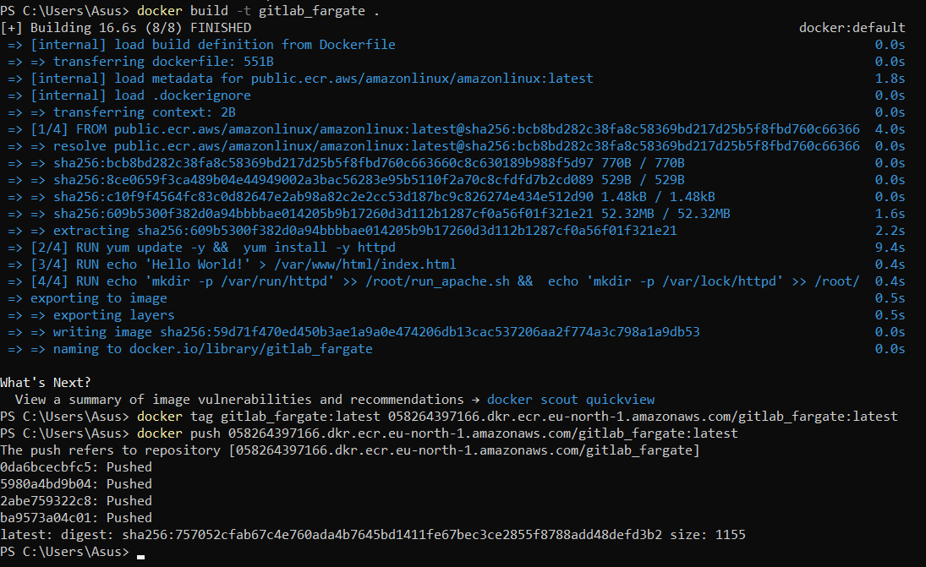
3.7. Push Docker image to ECS repository

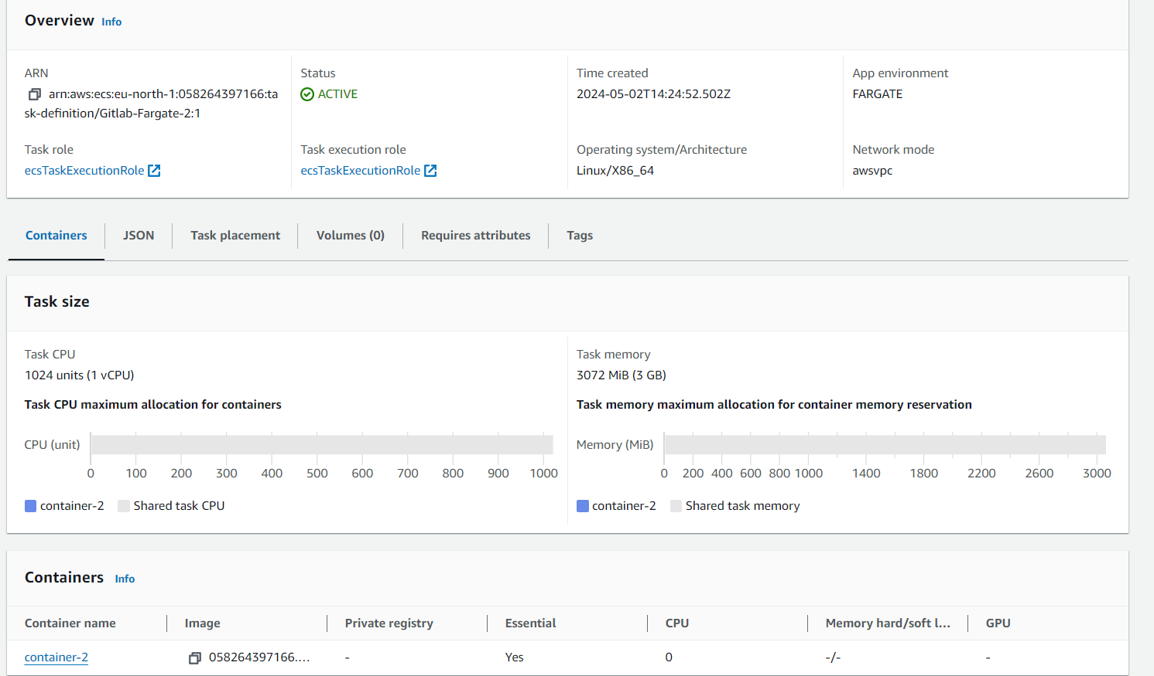
3.8. Create task definition that used the Docker Image

Task 3 Summary
The "GitLab + Fargate" section of our lab aimed to demonstrate how GitLab can be used to manage and automate the deployment of applications using AWS Fargate, which is a serverless compute engine for containers that eliminates the need to provision and manage servers. This section involved setting up an Amazon ECS cluster, defining tasks in Fargate, and creating a container repository.

During our lab, we successfully set up the necessary AWS infrastructure, including the ECS cluster and task definitions, and integrated these components with GitLab. Our objective was to utilize GitLab's CI/CD pipelines to automate the deployment of containerized applications directly to Fargate, leveraging GitLab’s ability to handle complex workflows efficiently.

However, we encountered issues when attempting to run the pipeline in GitLab, which prevented us from successfully deploying our application. These challenges highlighted some of the complexities and potential configuration pitfalls when integrating multiple cloud services and tools. Despite these setbacks, the exercise provided valuable insights into the capabilities and limitations of using GitLab with AWS Fargate, and it pointed out areas where additional troubleshooting and configuration adjustments are necessary.

PART 4: GITLAB + EKS
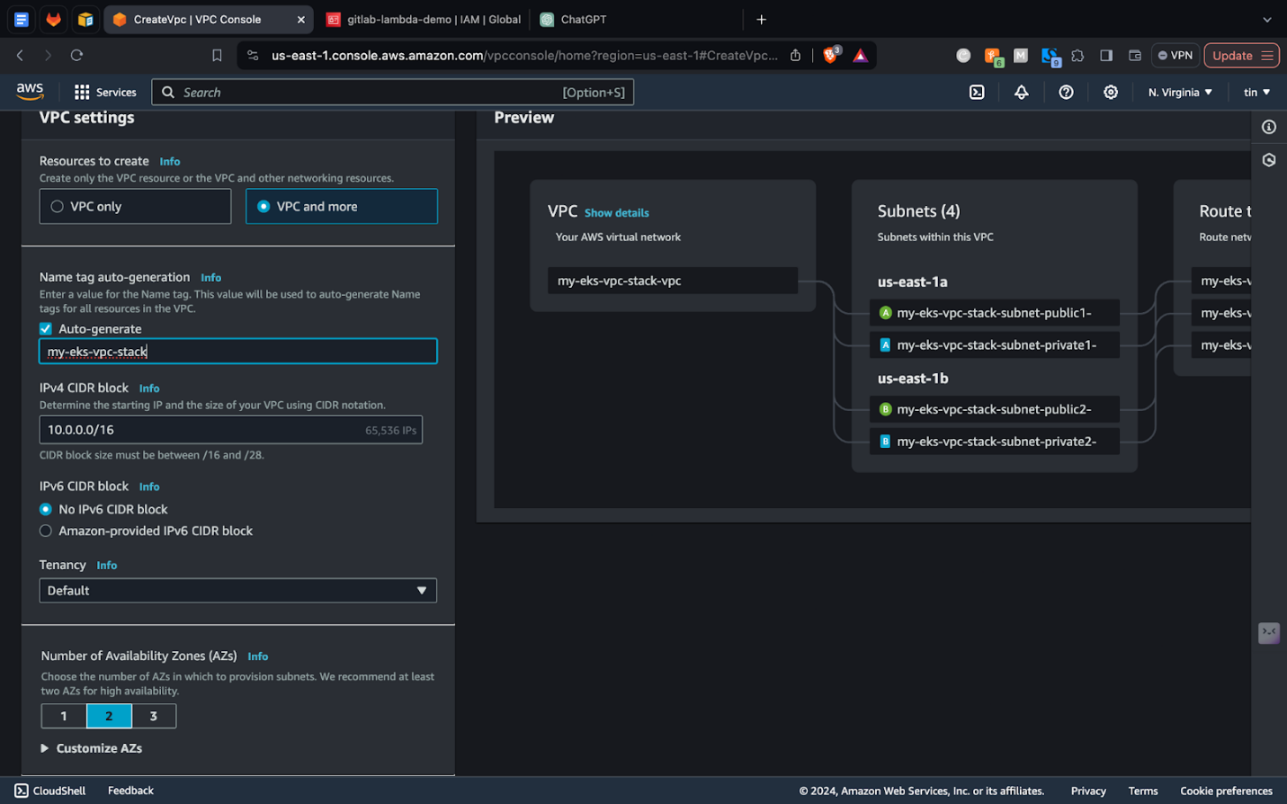
4.1. Create an Amazon VPC with public and private subnets that meets Amazon EKS requirements
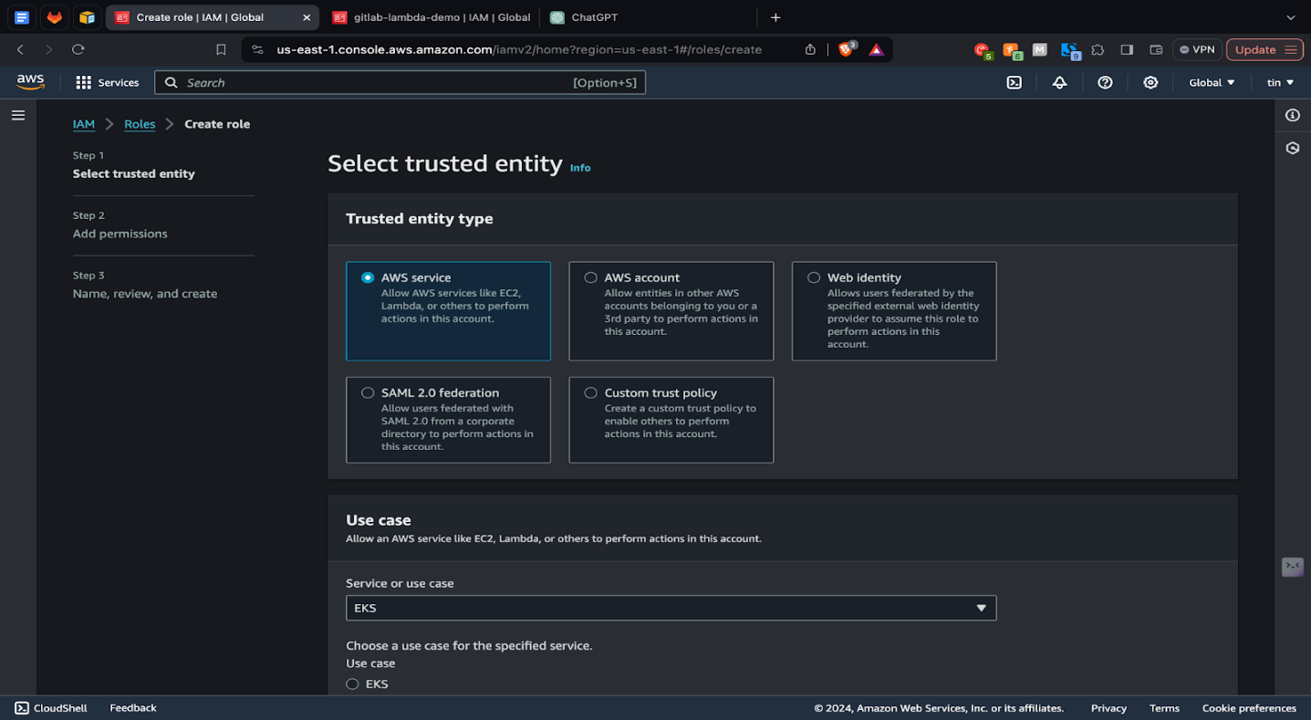
4.2. Create a cluster IAM role and attach the required Amazon EKS IAM managed policy to it
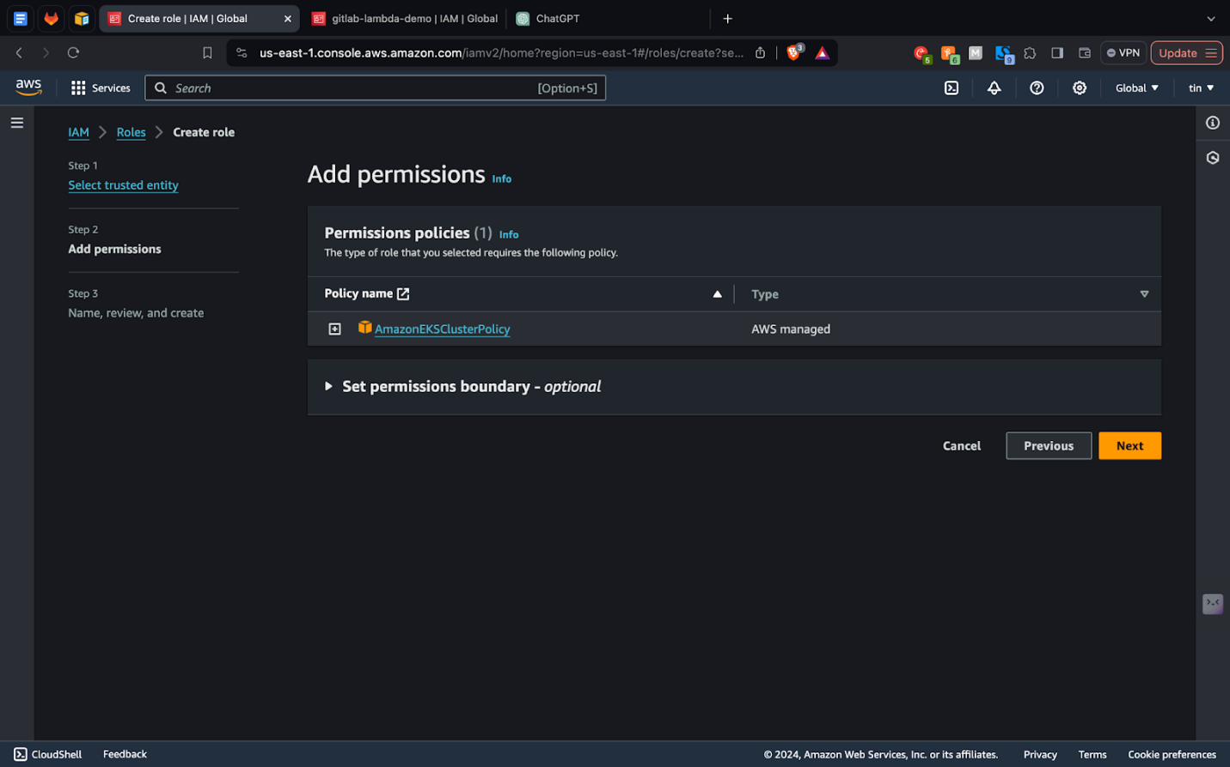
4.3. Adding the permissions policy to the IAM role
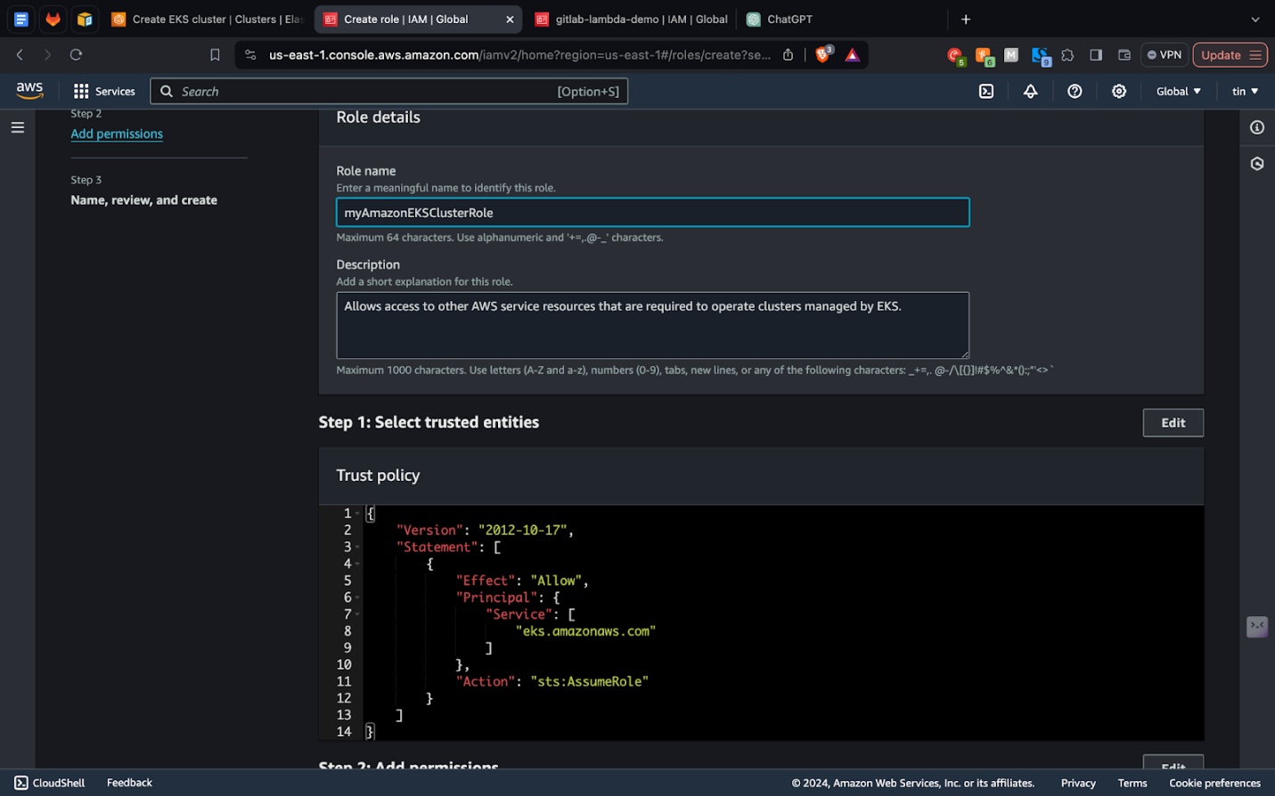
4.4. Specify role name
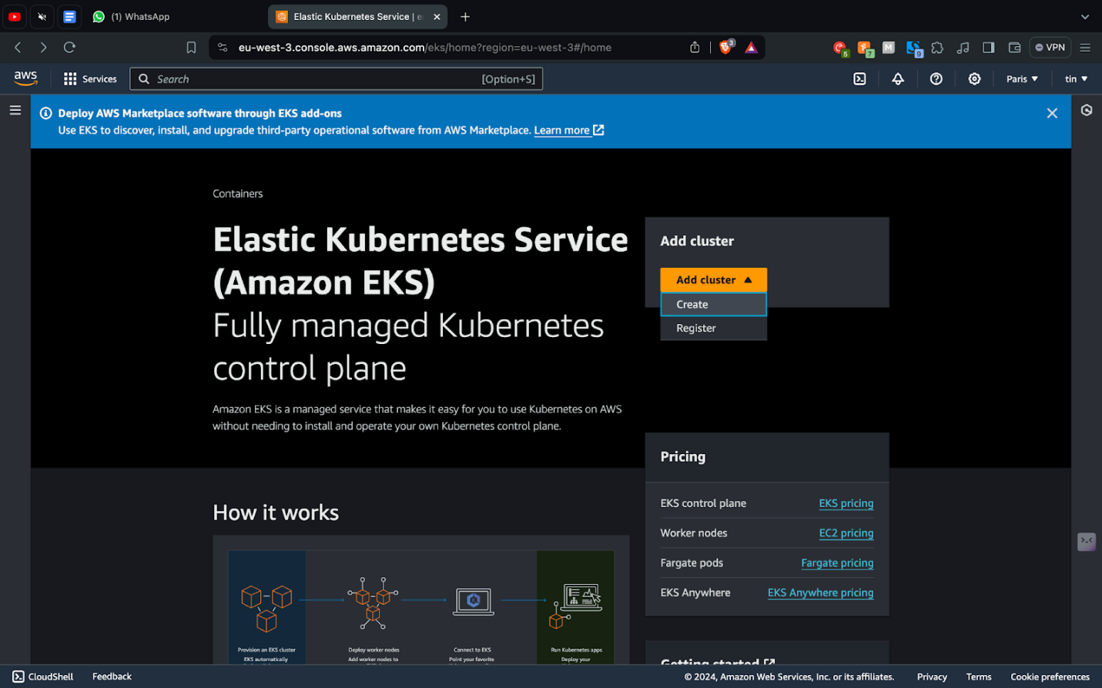
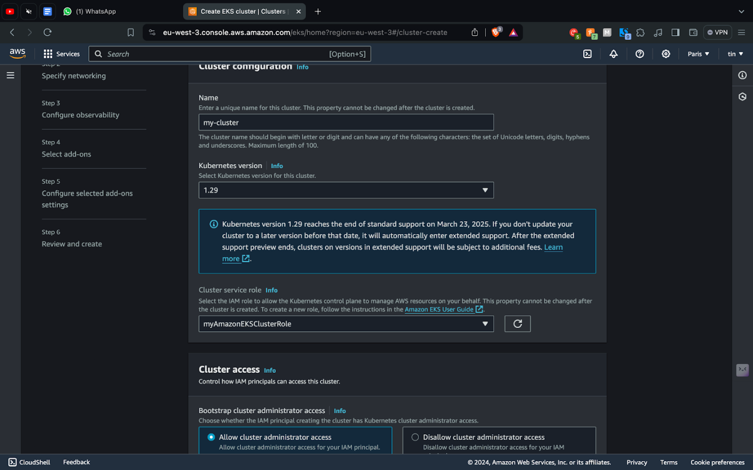
4.5. Create EKS cluster

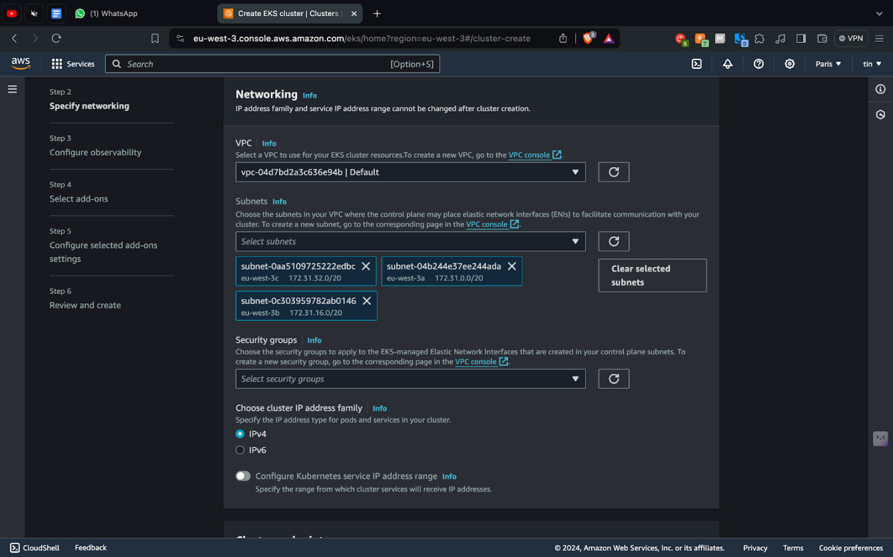
4.6. Adding the VPC created above
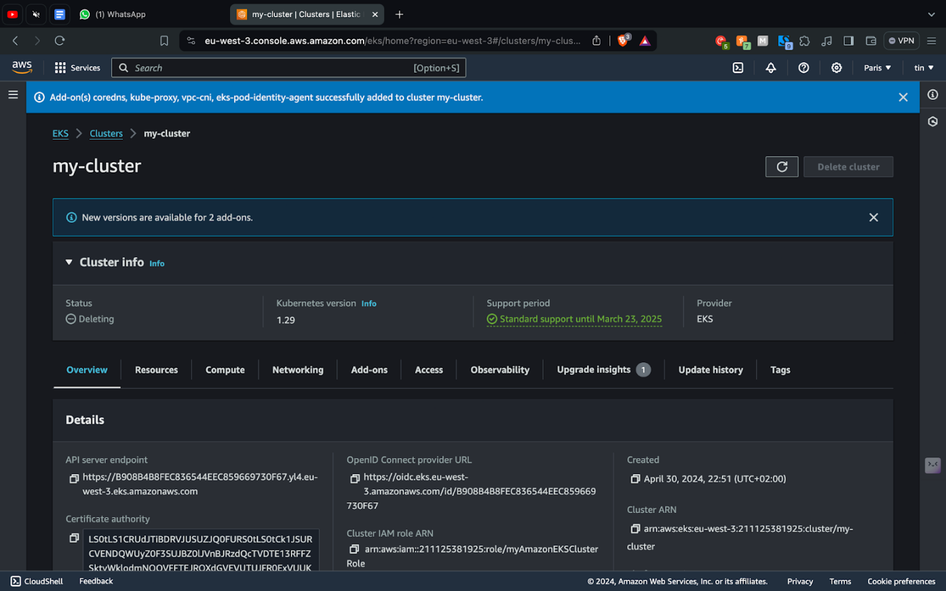
4.7. EKS cluster created successfully
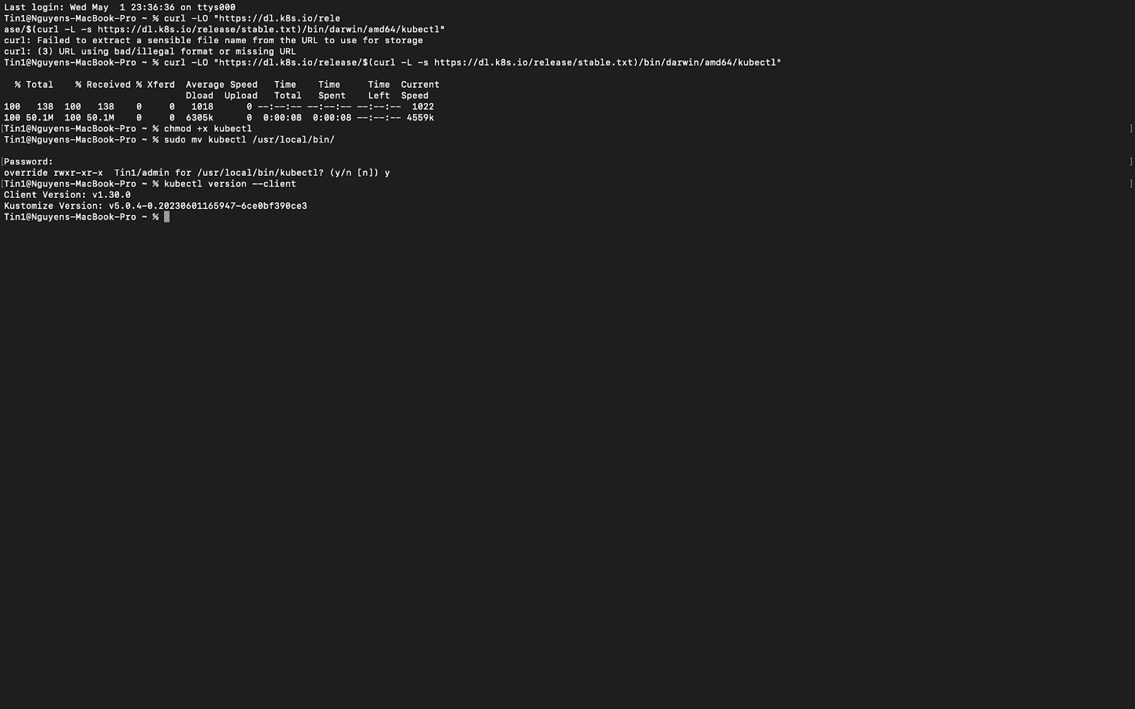
4.8. Download kubectl
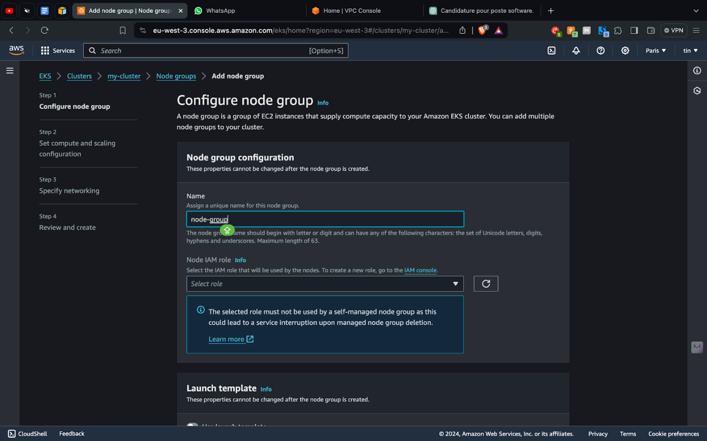
4.9. Configure node group for the cluster
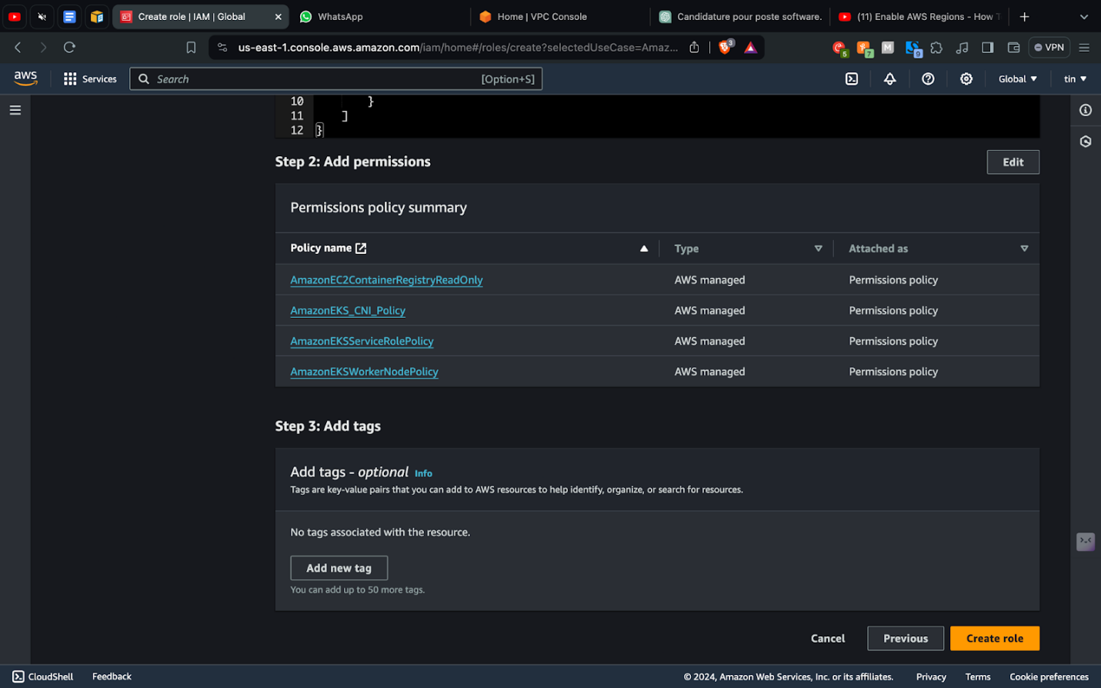
4.10. Add permission to node group
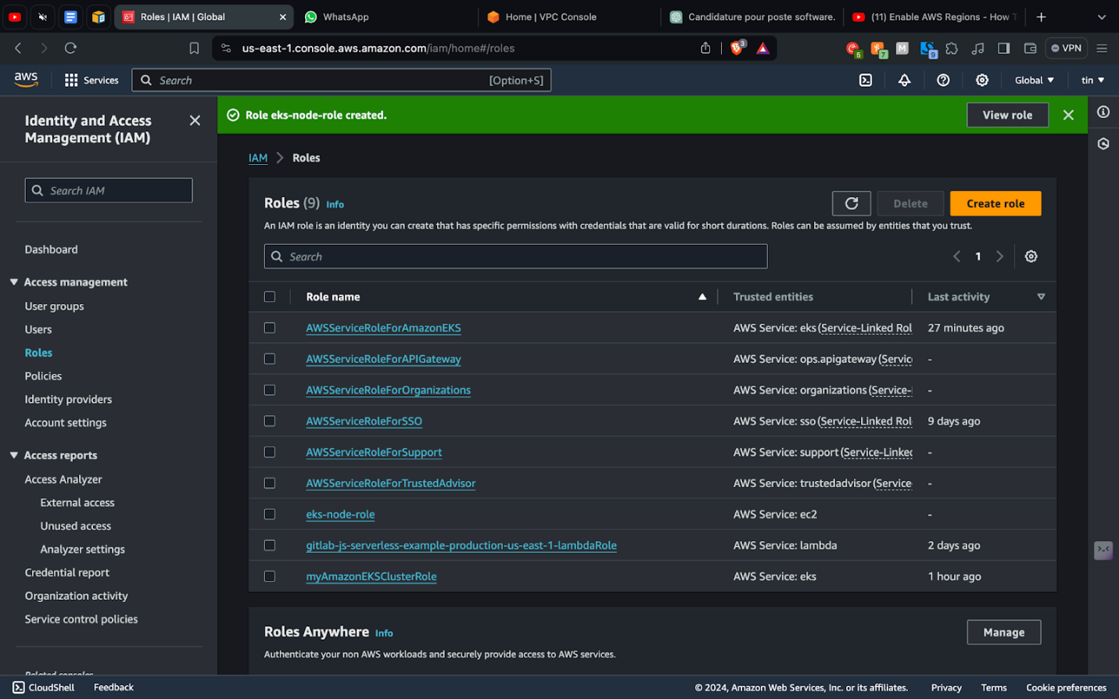
4.11. Add roles to node group
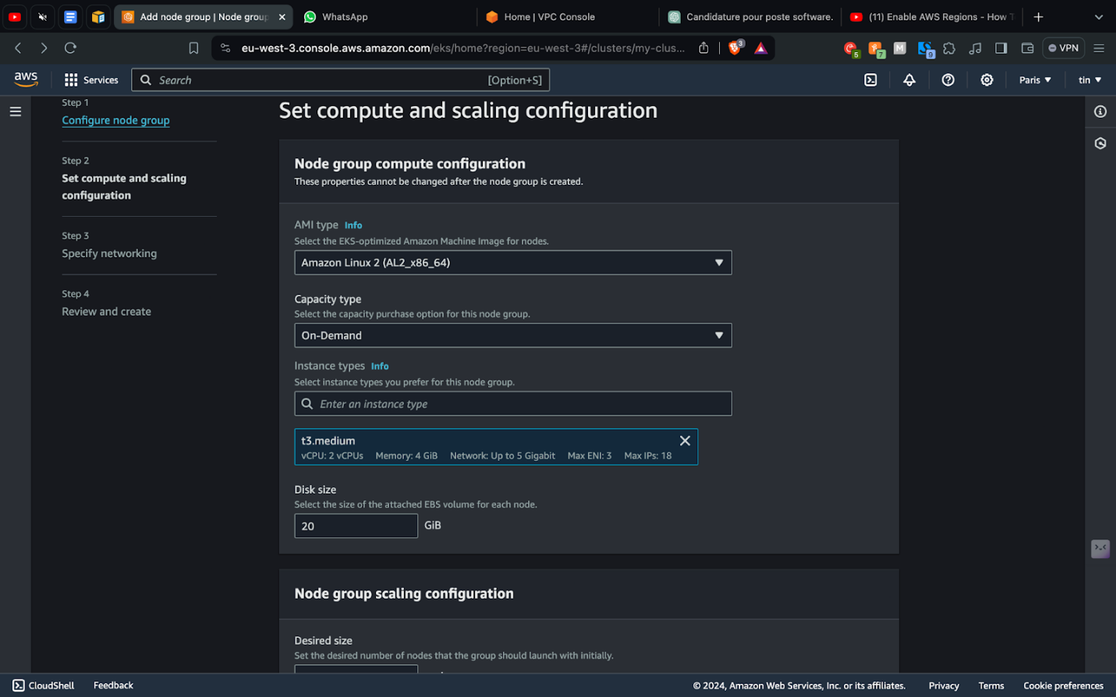
4.12. Node group compute configuration
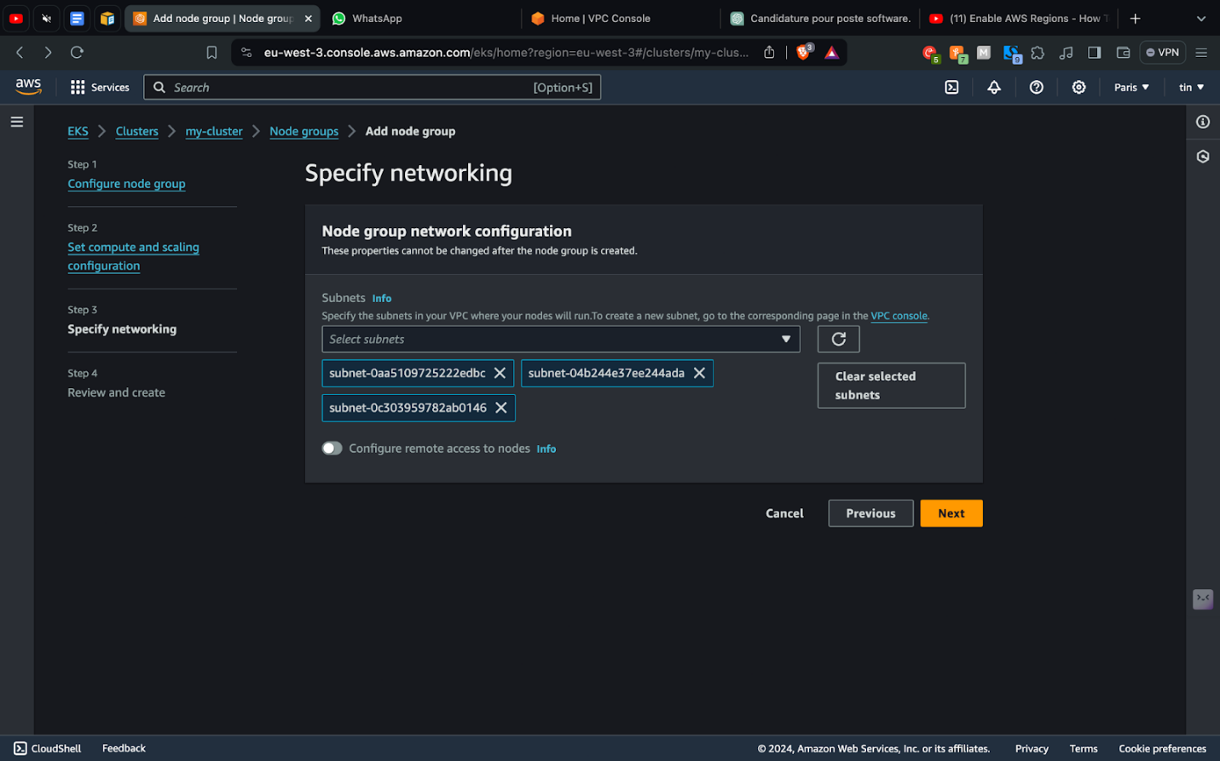
4.13. Specify network configuration
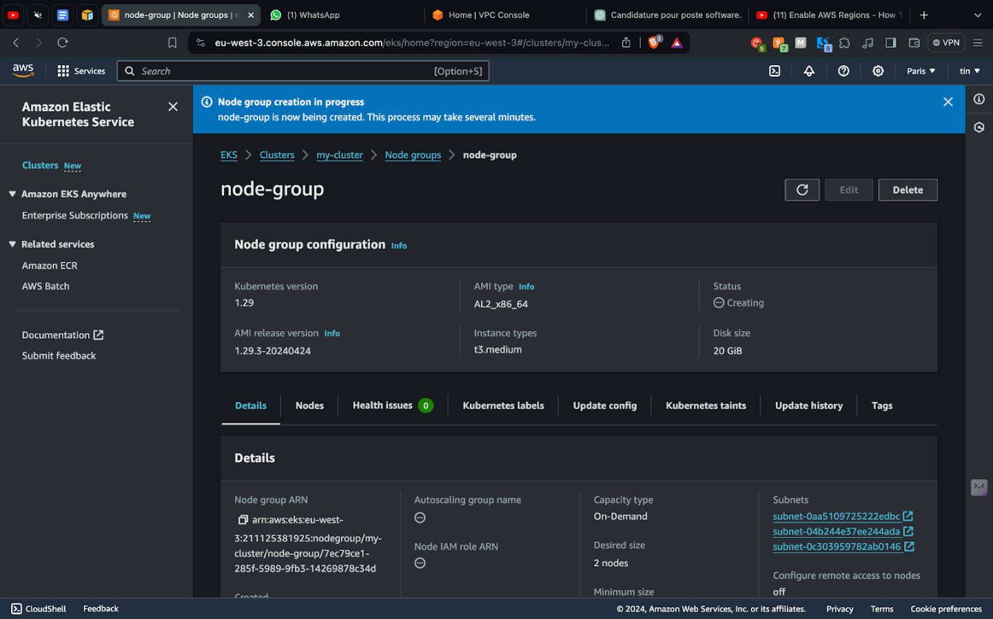
4.14. Node group created
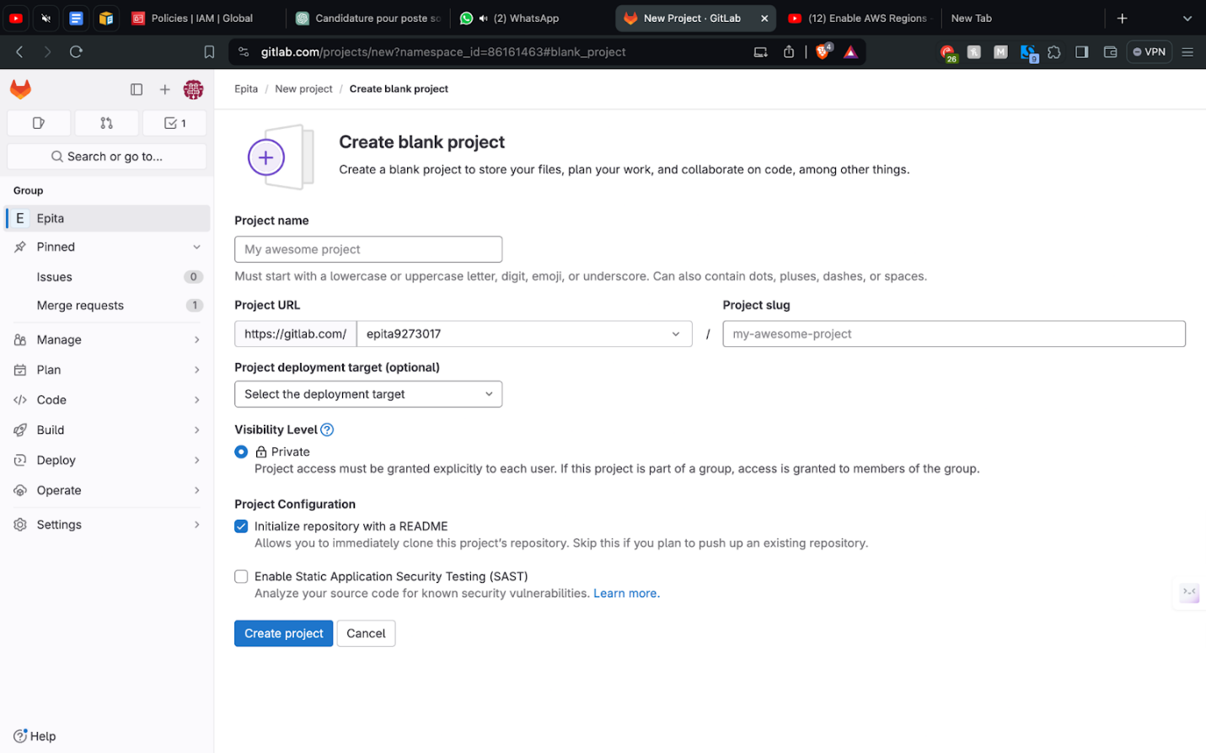
4.15. Create a blank project in Gitlab
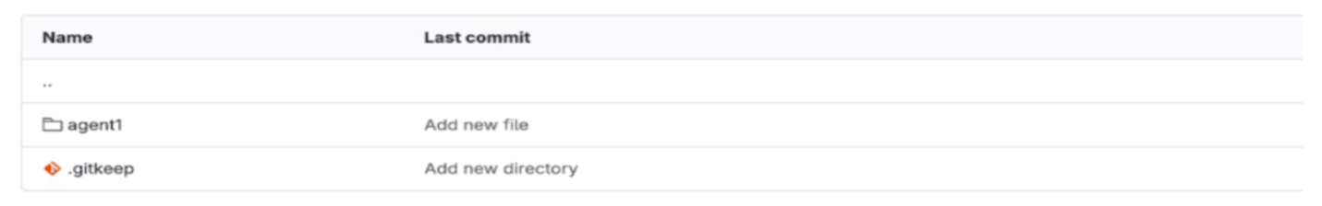
4.16. Make sure the directory is tracked by adding .gitkeep file
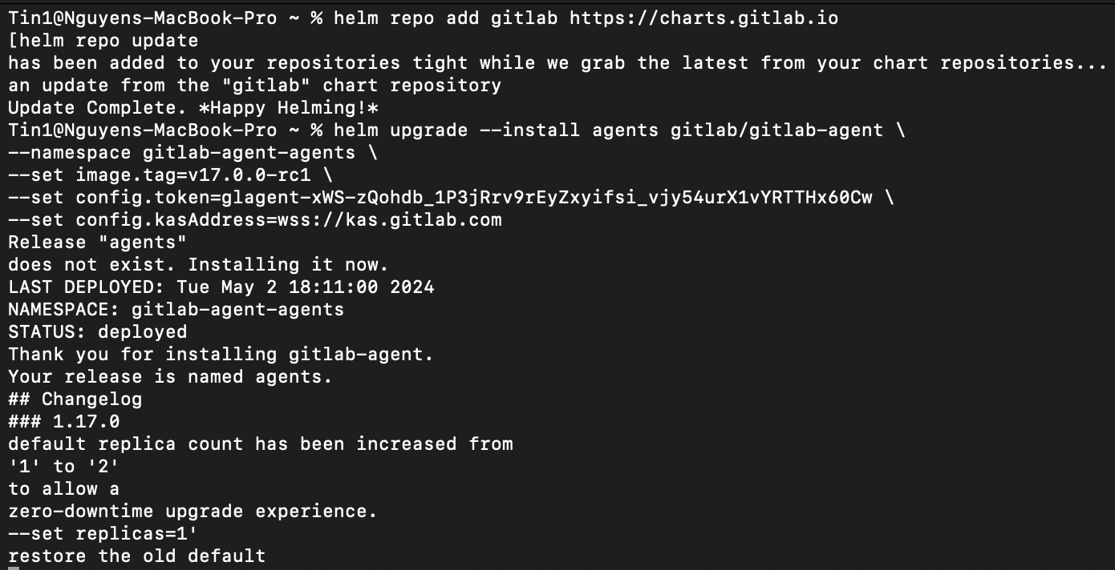
4.17. Successful Helm Repository Update and GitLab Agent Deployment

Task 4 Summary:
The "GitLab + EKS" (Amazon Elastic Kubernetes Service) section of our lab focused on leveraging GitLab to manage and deploy applications within a Kubernetes environment provided by AWS EKS. Amazon EKS is a managed Kubernetes service that simplifies running Kubernetes clusters without needing to install or maintain your own Kubernetes control plane. It's designed to provide more secure, scalable, and high-performing infrastructure for deploying containerized applications.

In our lab, we engaged in the setup and integration of GitLab with EKS to streamline the deployment process. The lab tasks involved creating a Kubernetes cluster through the EKS service, which included configuring various AWS resources like IAM roles and security groups. We also explored how to integrate these resources with GitLab to take advantage of GitLab’s Auto DevOps capabilities, which automate tasks such as building, testing, and deploying applications.

This setup intended to demonstrate a seamless workflow for continuous integration and deployment, optimizing resource use, and simplifying operations. By using GitLab with EKS, we aimed to create a highly efficient pipeline that could dynamically scale based on the needs of the development and production environments.

During the process, we successfully completed the initial setup of the Kubernetes cluster and configured the necessary IAM roles for authentication and authorization between AWS and GitLab. This setup enabled us to manage our Kubernetes resources directly from GitLab, enhancing our development operations by providing a single interface for all stages of application development and deployment. The integration showcases how GitLab and EKS can work together to provide a robust solution for managing containerized applications at scale.

PART 5: GITLAB + EC2
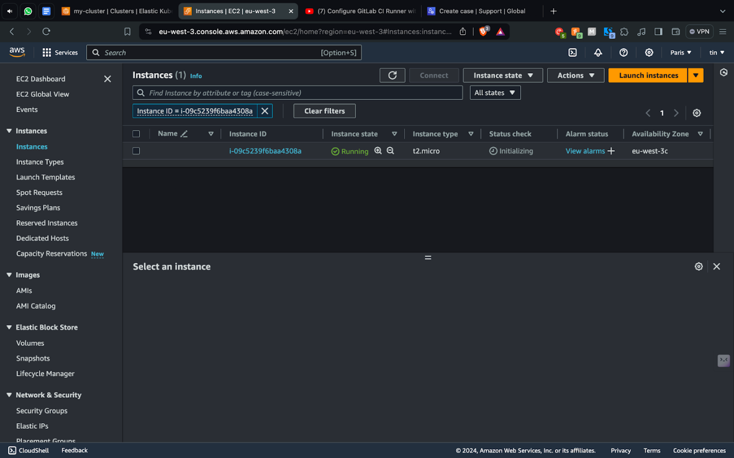
5.1. Connect instance
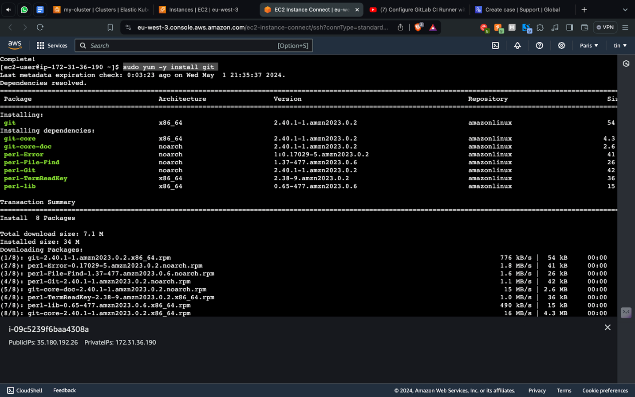
5.2. Install git
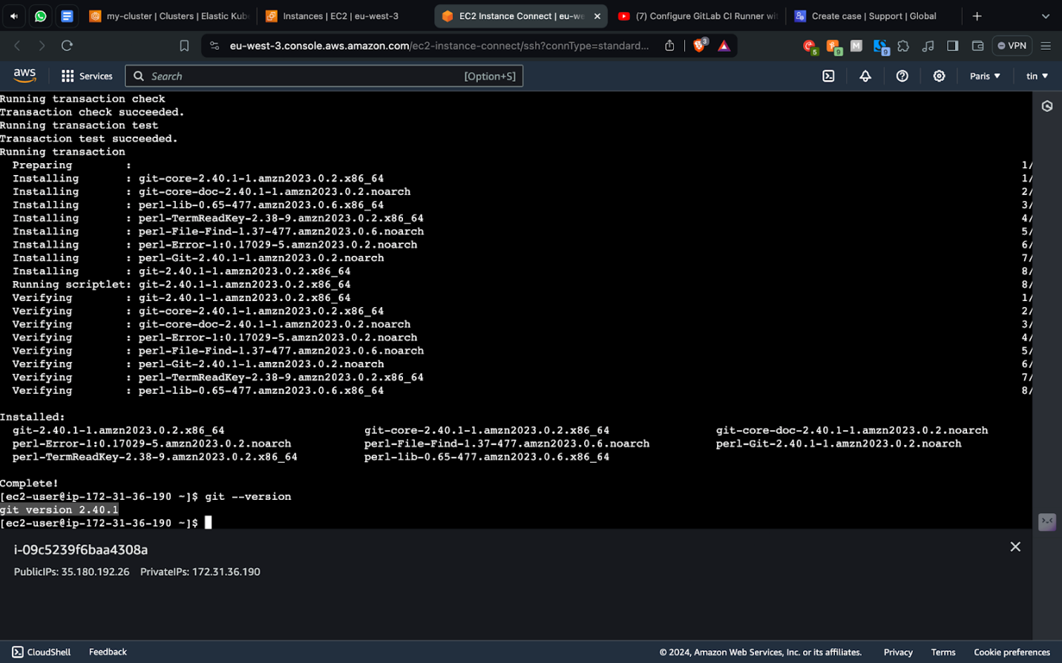
5.3. Make sure git is installed
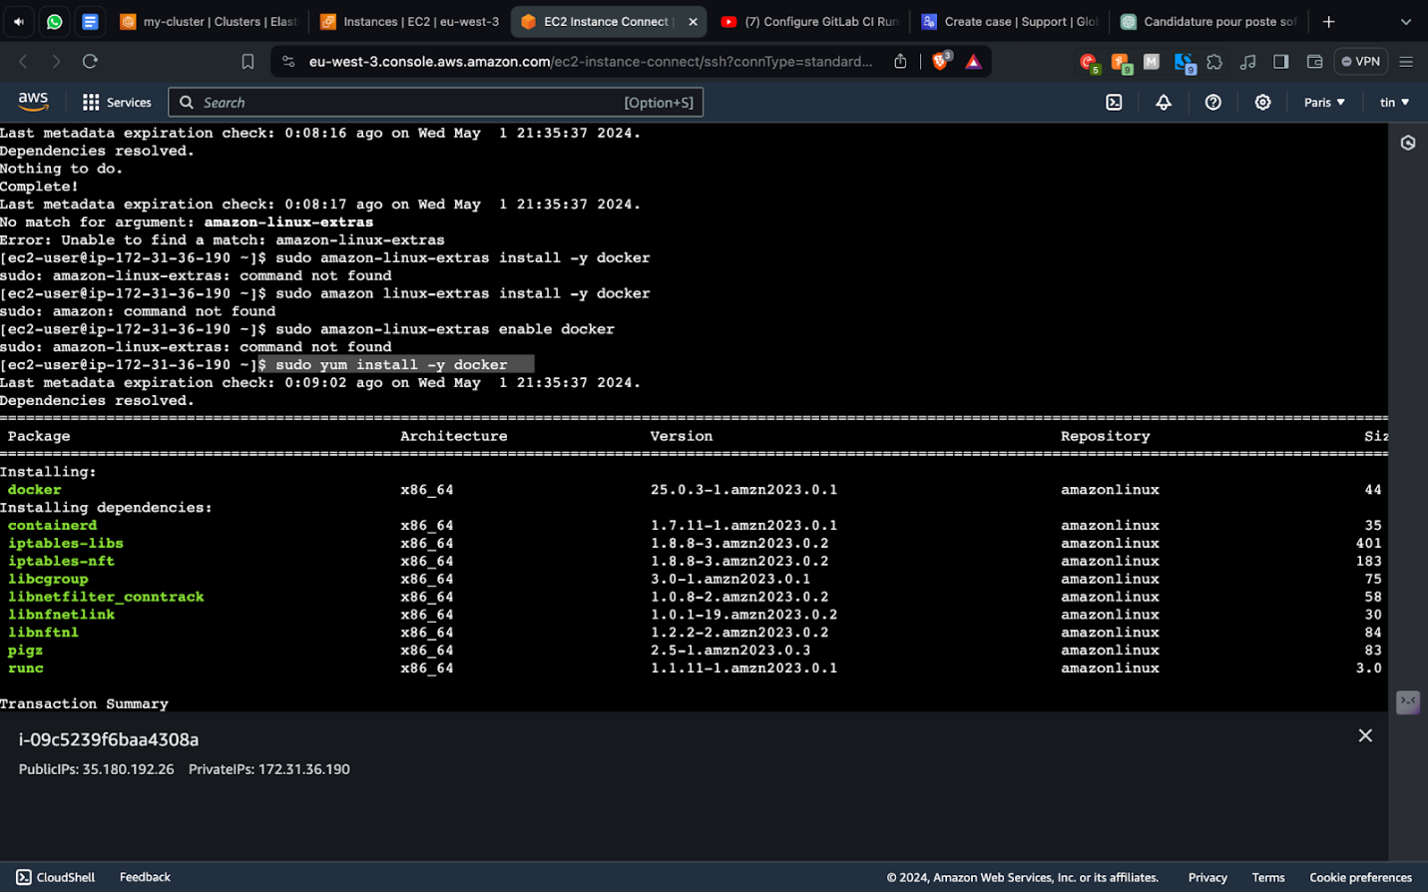
5.4. Install Docker
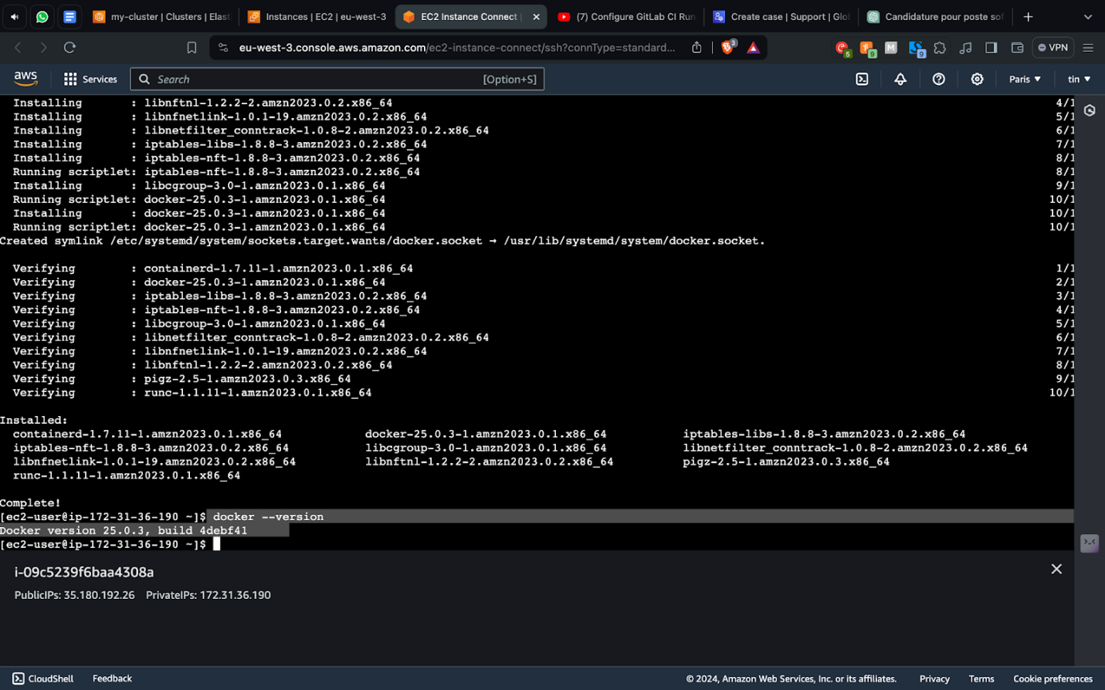
5.5. Make sure Docker is installed
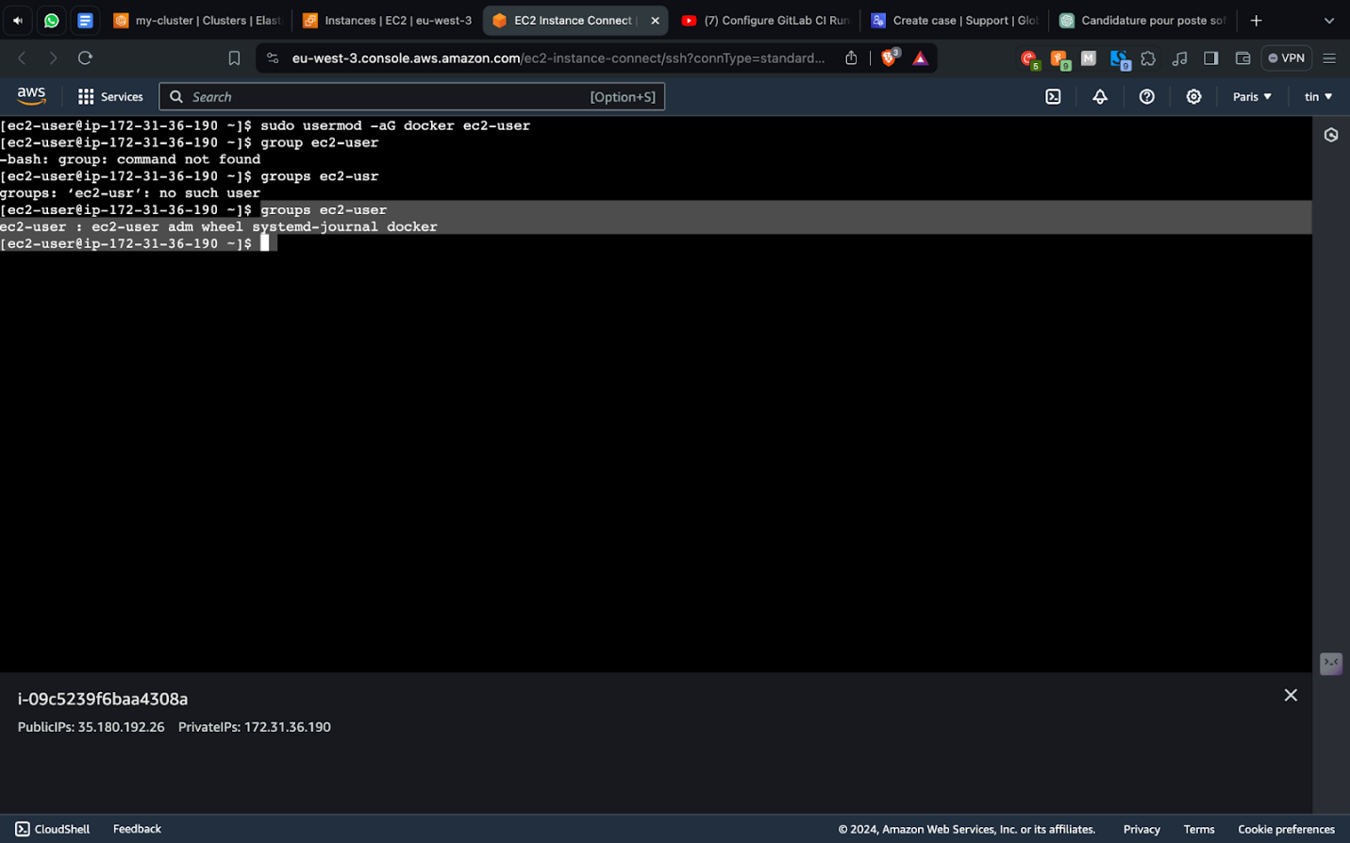
5.6. Check which group is EC2-user
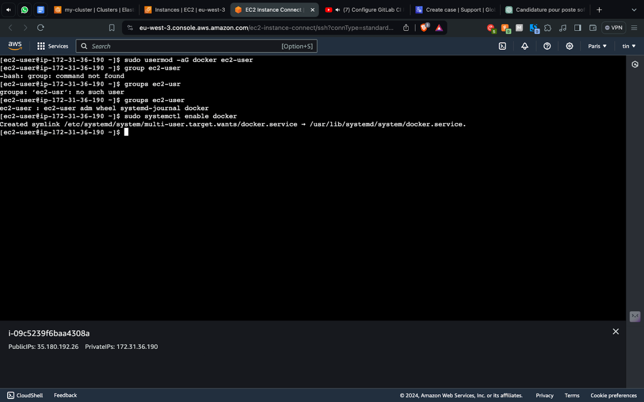
5.7. Make sure Docker start automatically
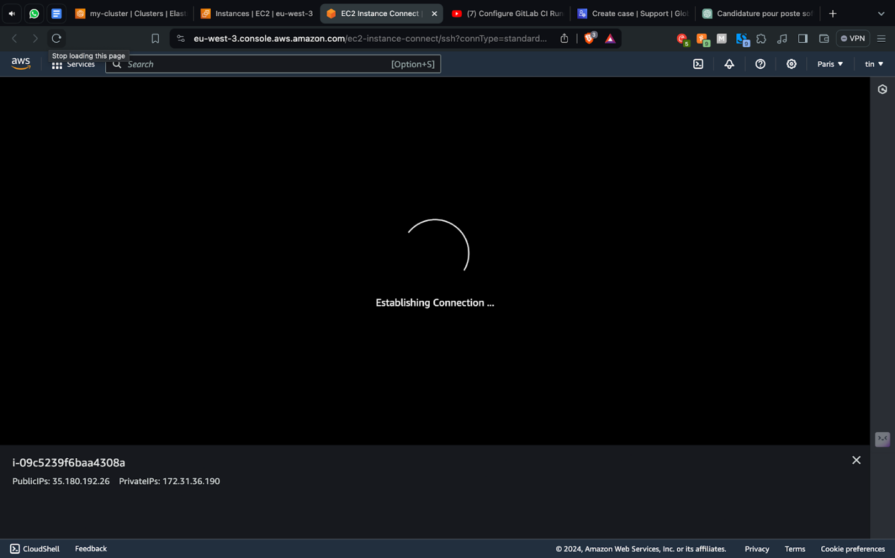
5.8. Restart the installation
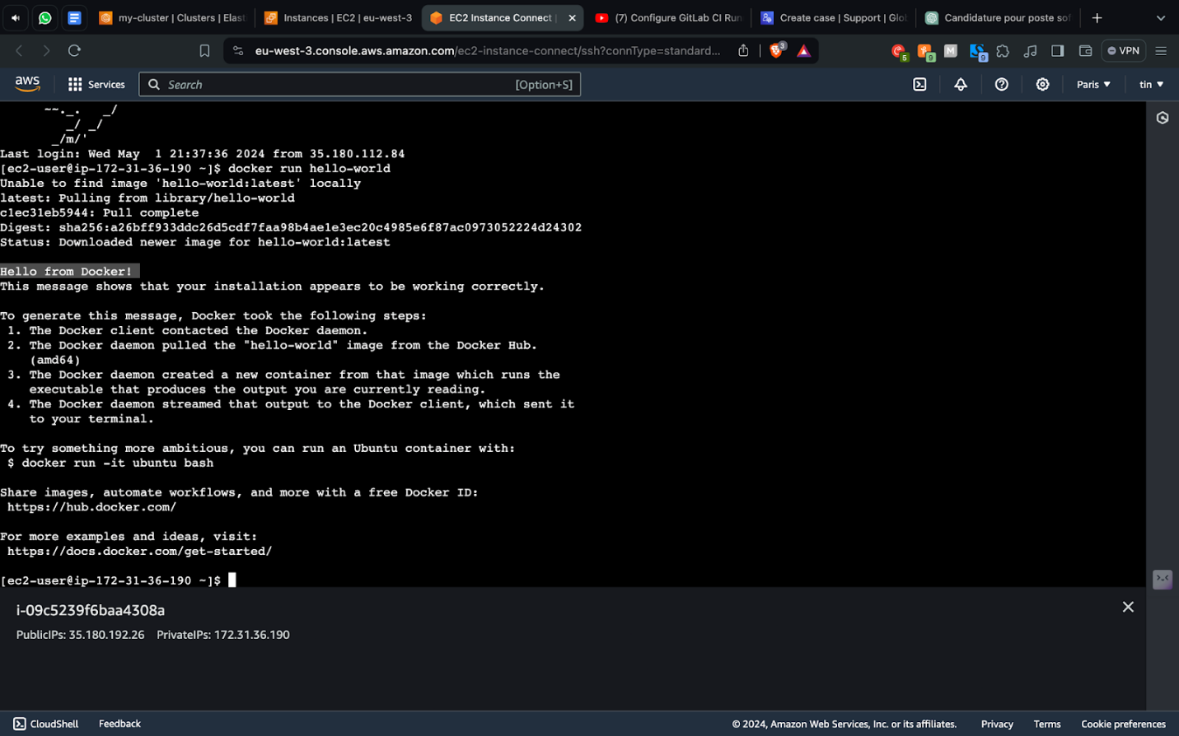
5.9. Make sure Docker is running
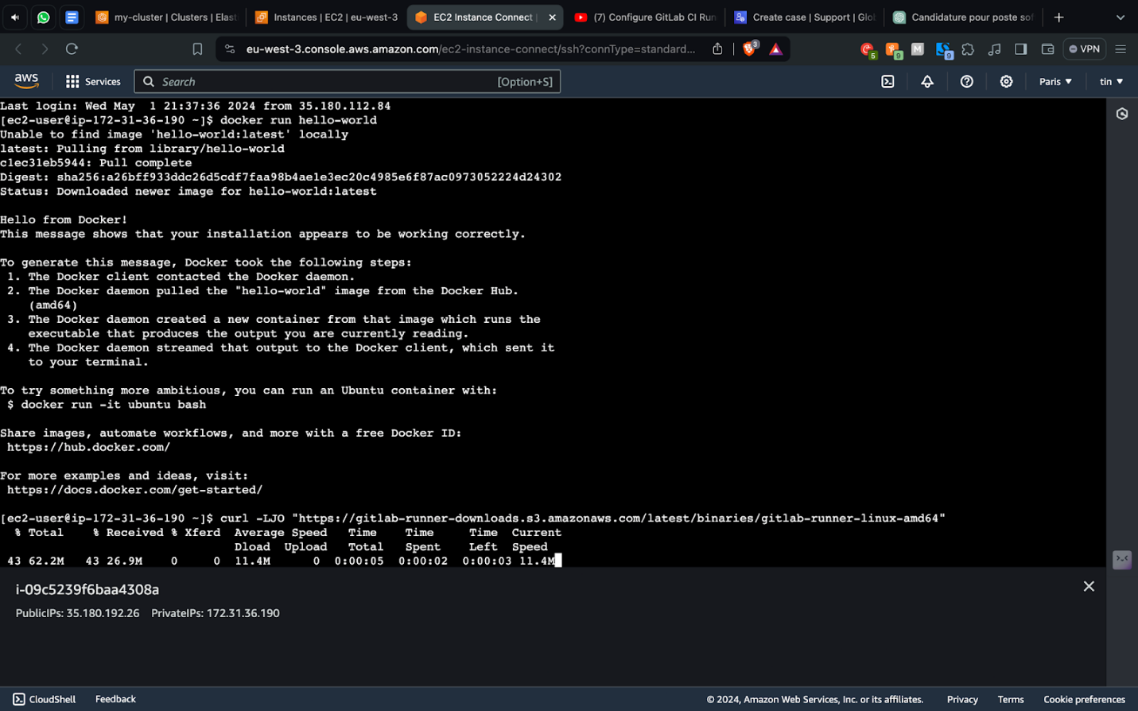
5.10. Download Gitlab Runner
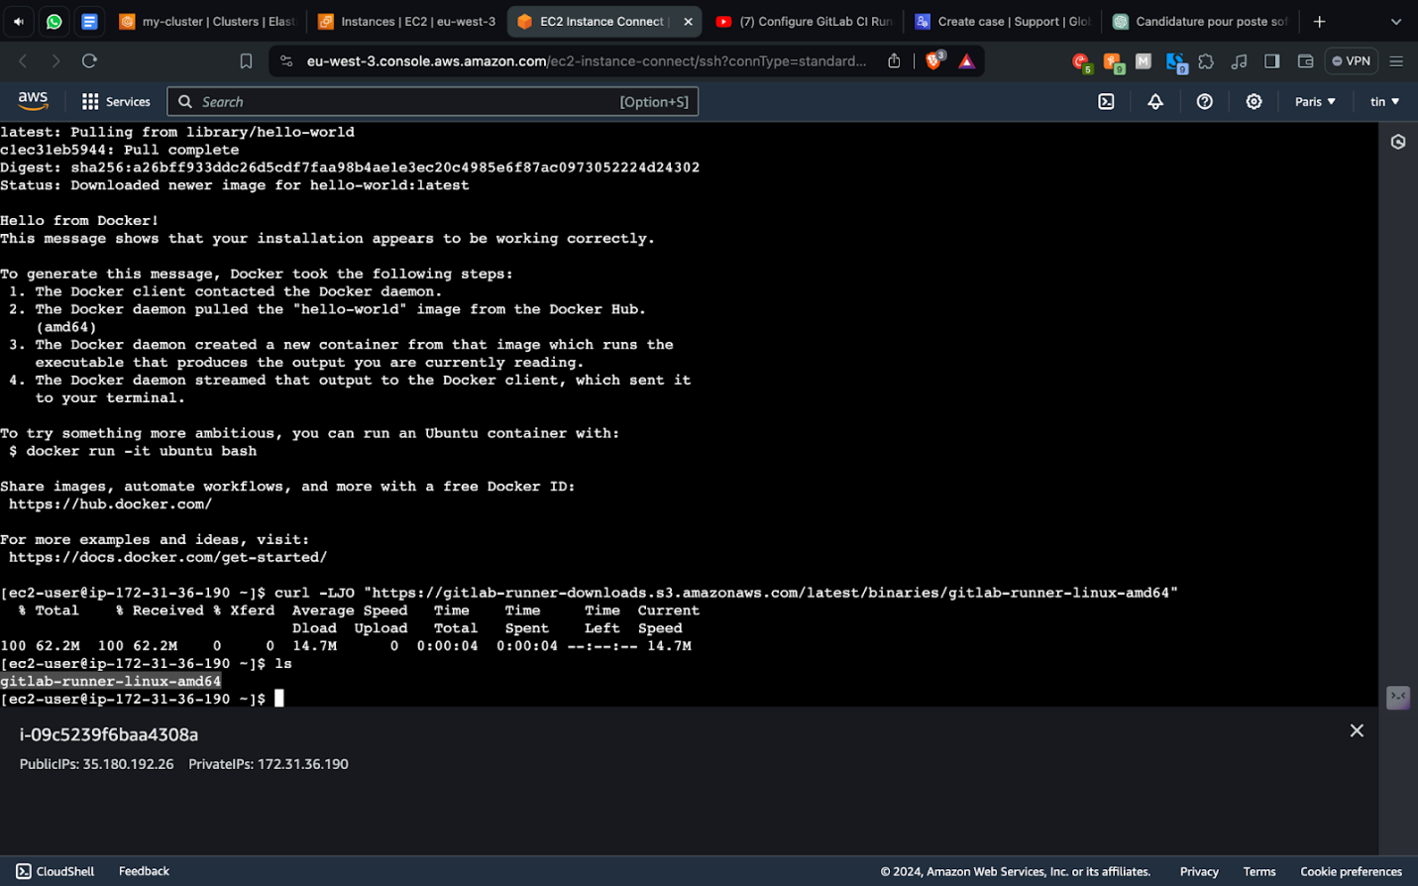
5.11. List out the file that are available
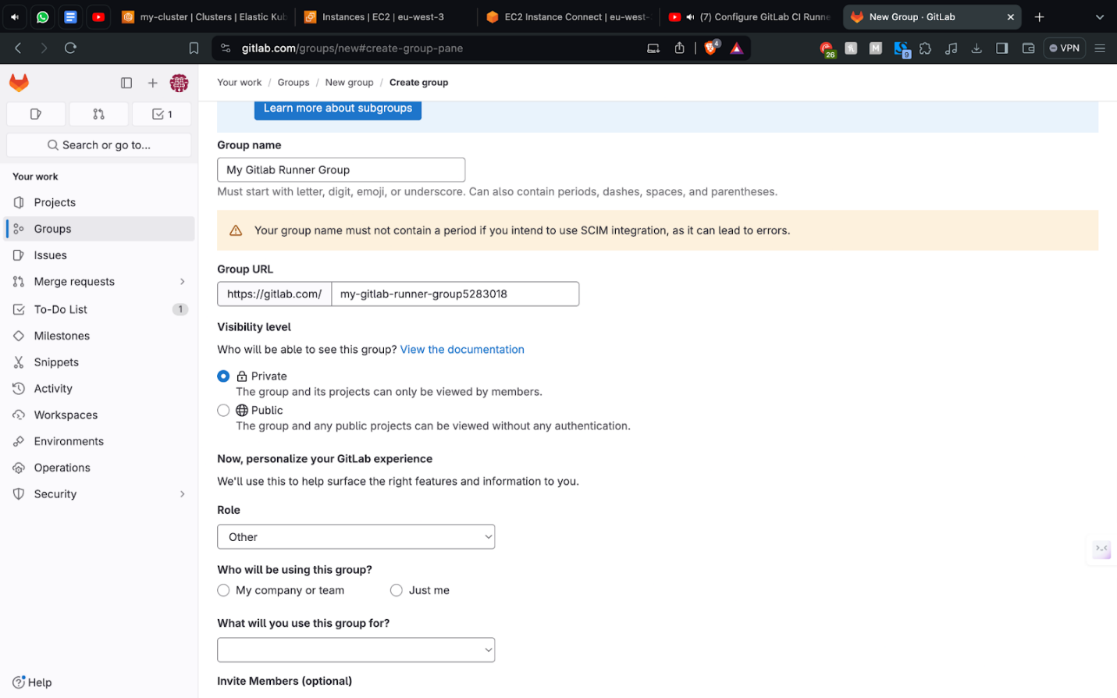
5.12. Create group lap
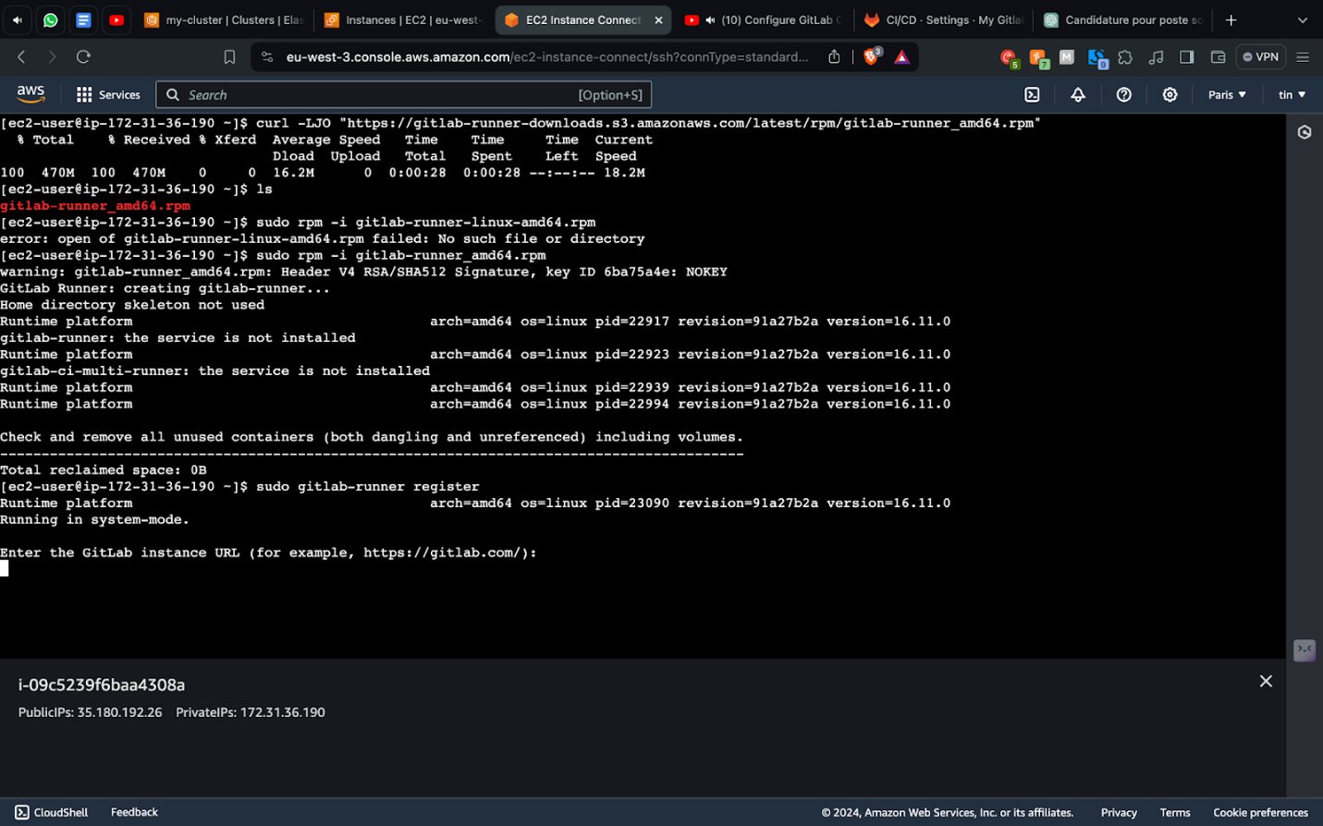
5.13. Register runner with the group
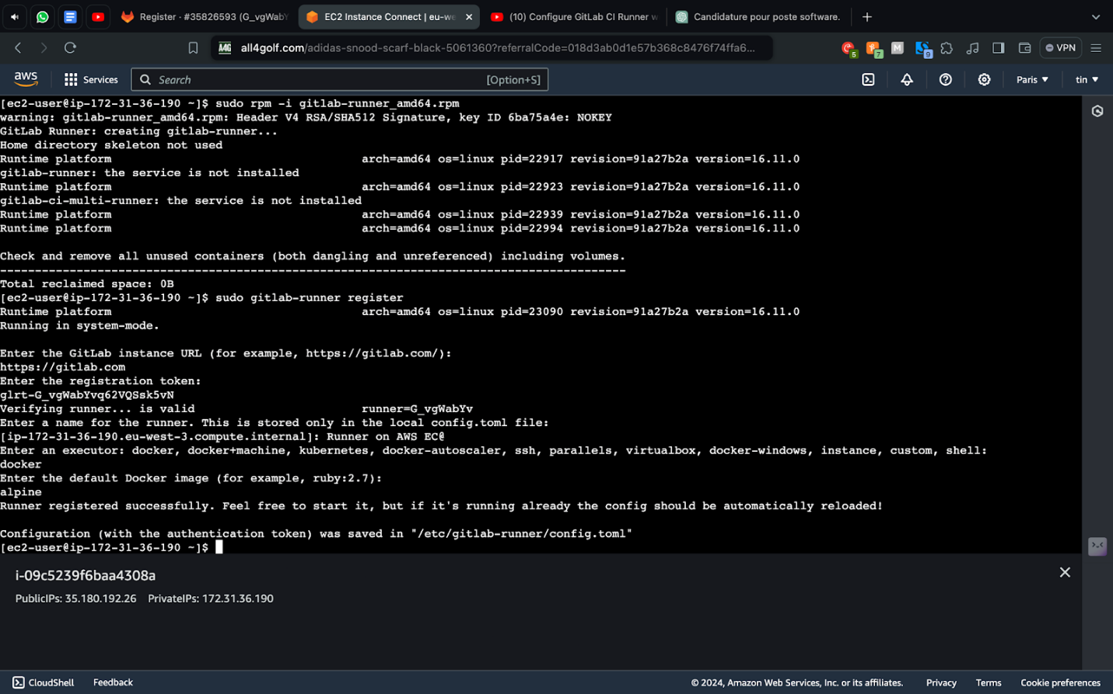
5.14. Specify Docker image
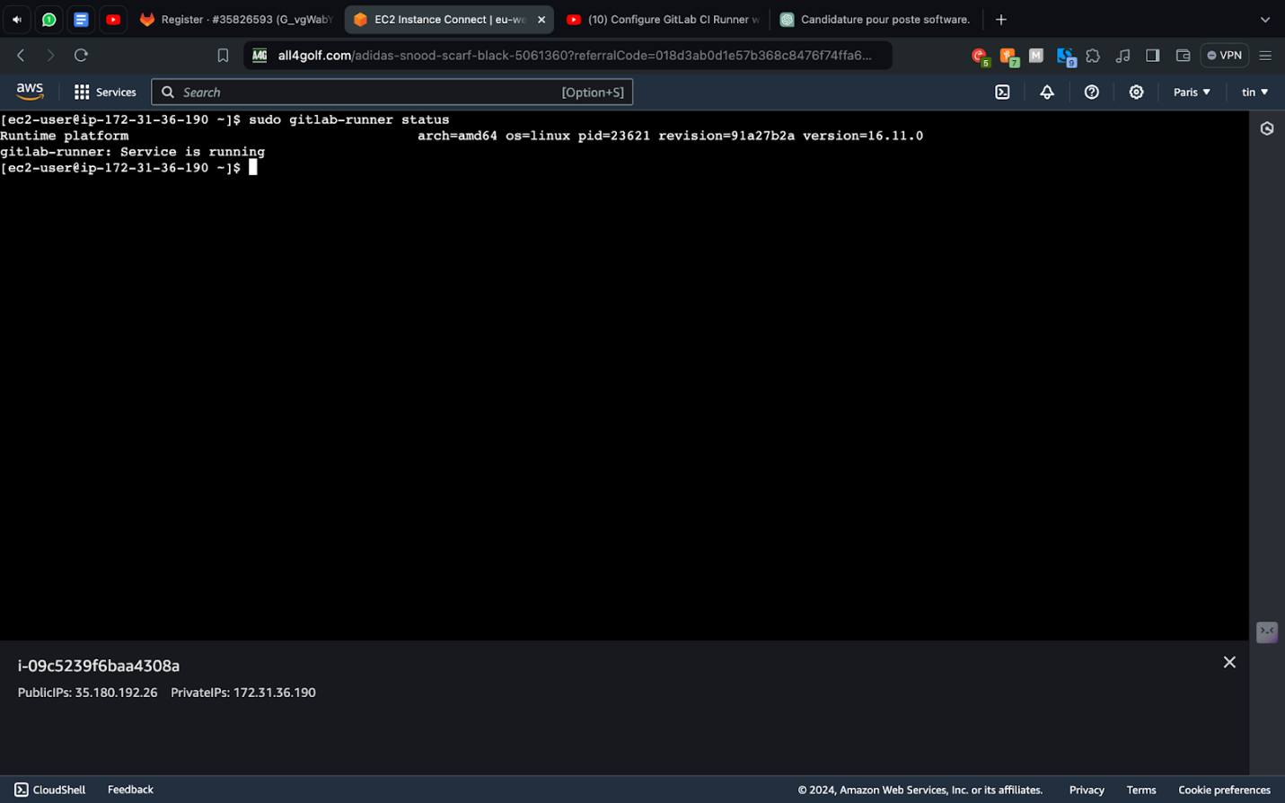
5.15. Check Gitlab runner status
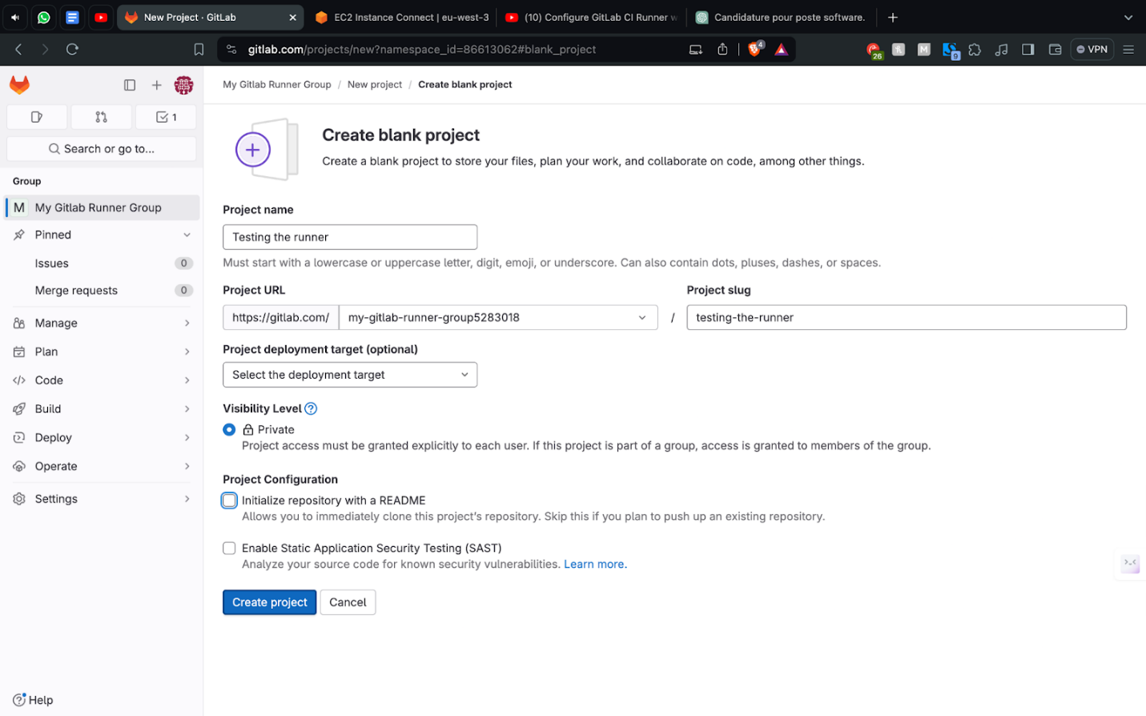
5.16. Create a blank project to test the runner
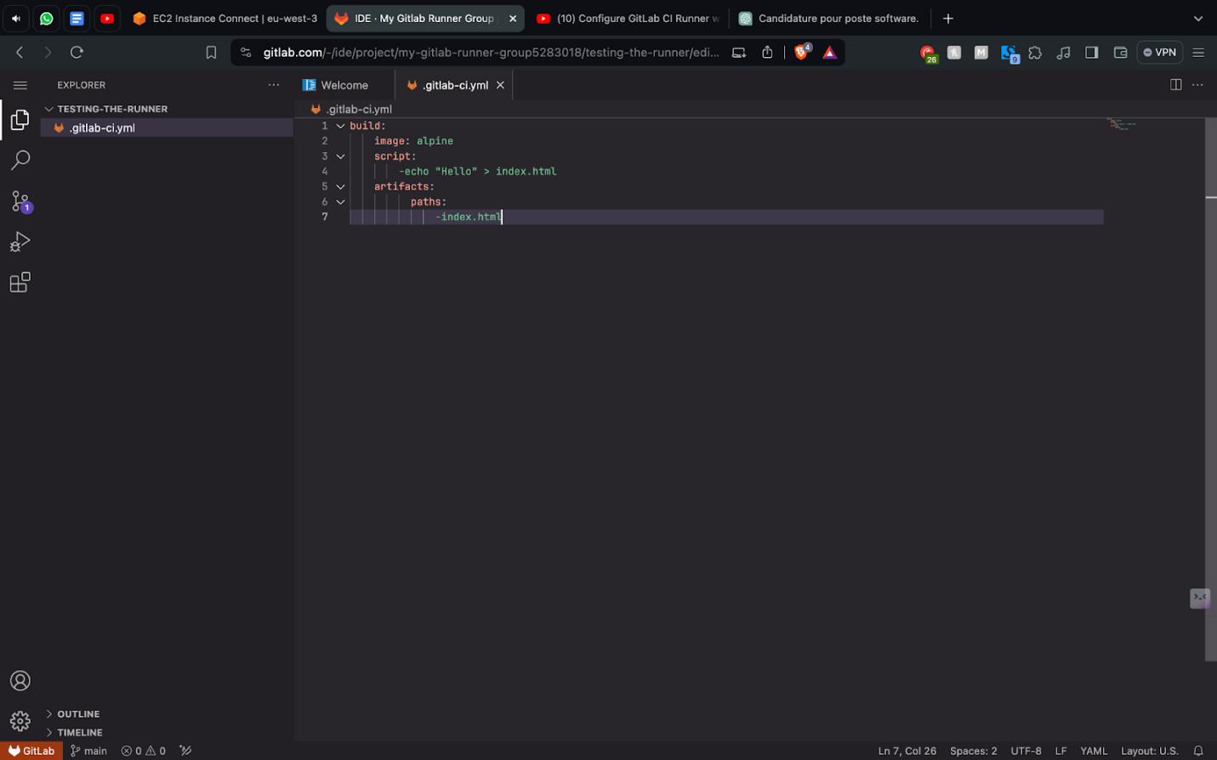
5.17. Create .gitlab-ci.yml file and write tests:
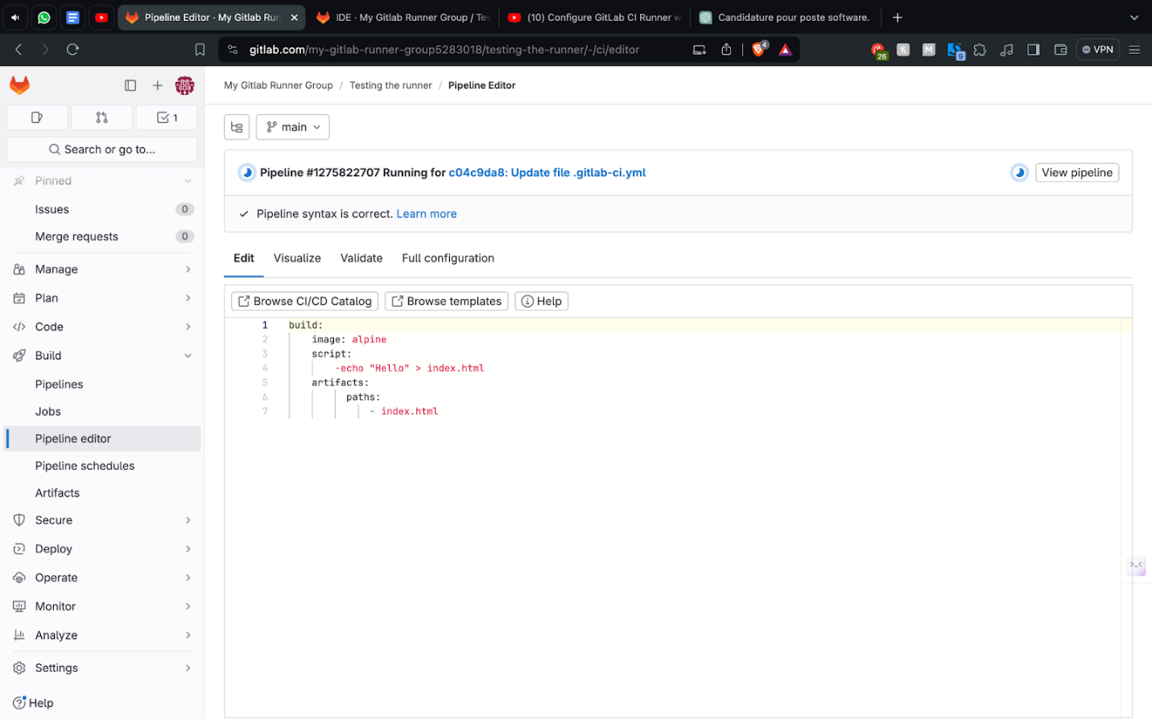
5.18. Test pipeline
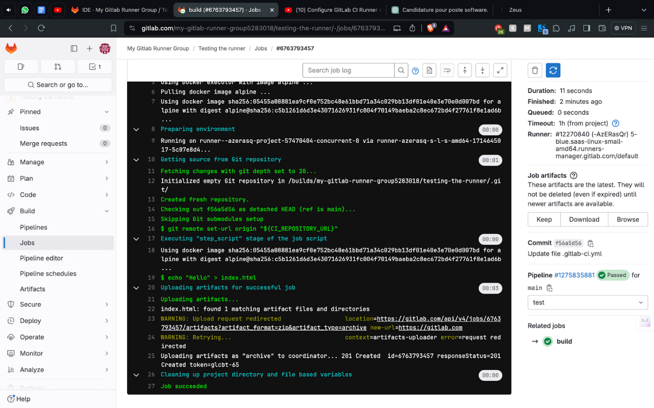
5.19. Test passed
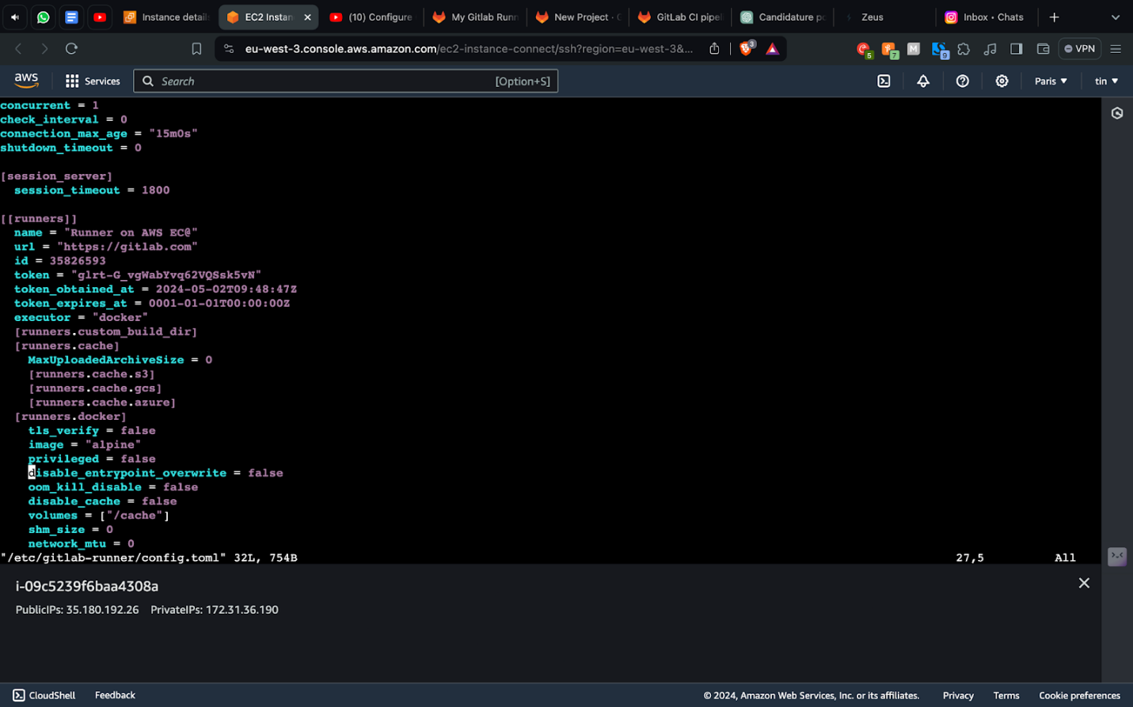
5.20. Enable privileged mode
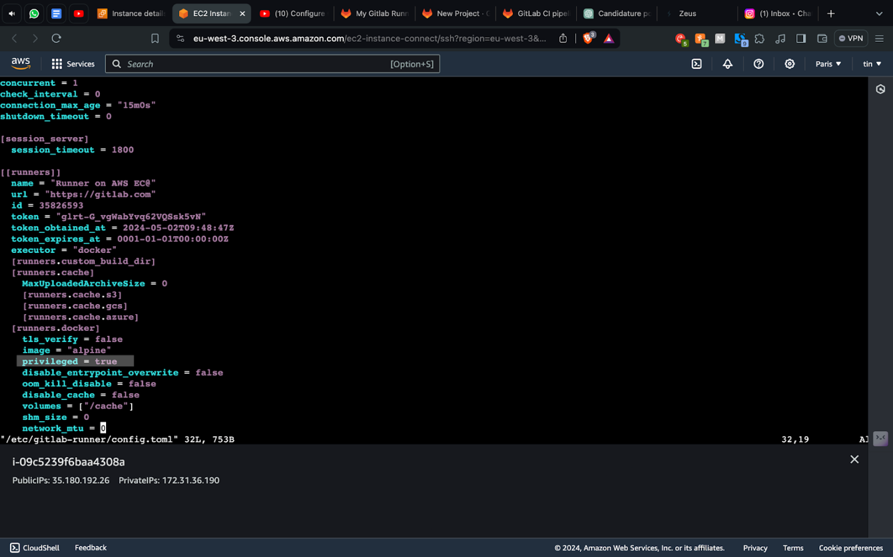
5.21. Change privileged mode to true
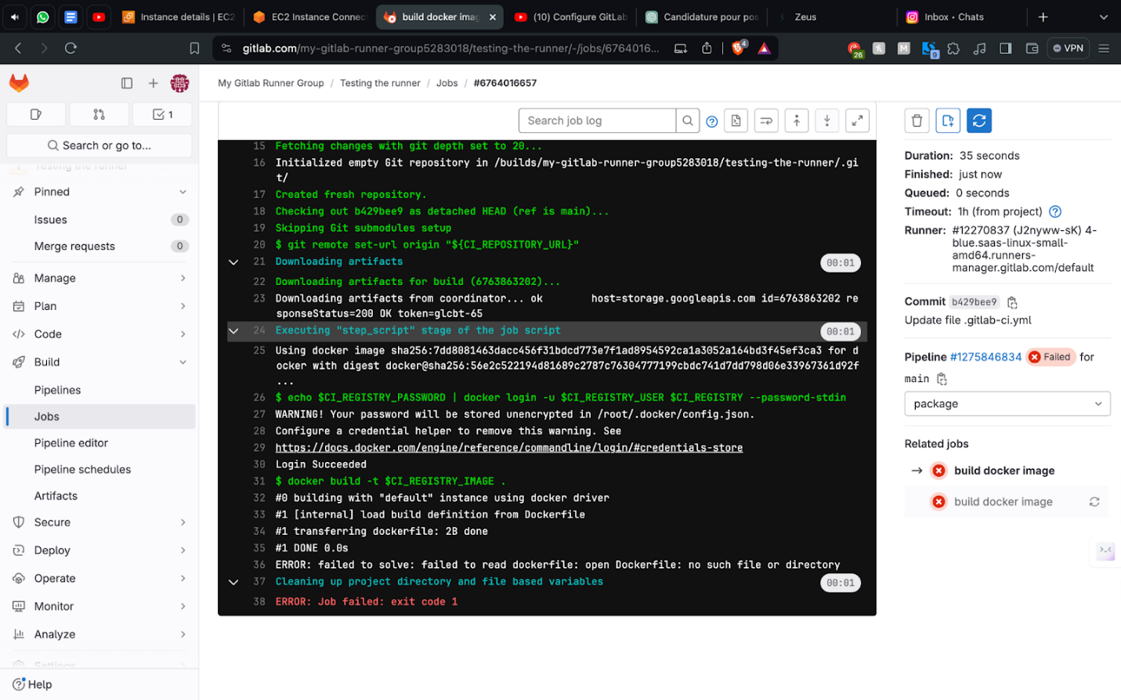
5.22. Pipeline failed because of not having dockerfile
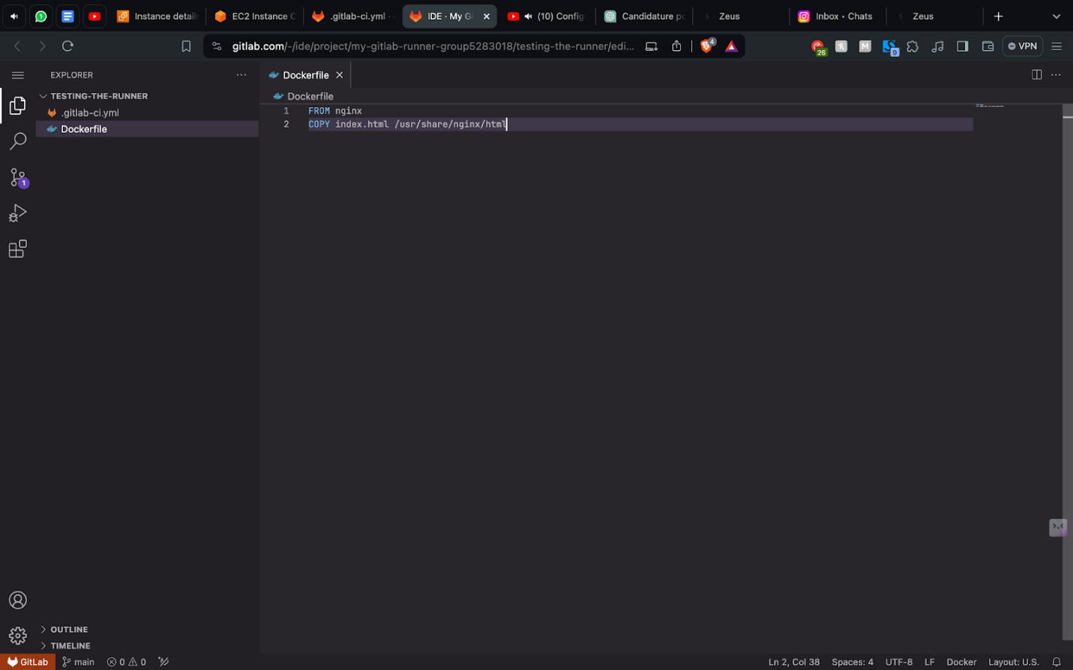
5.23. Docker is now working
Task 5 Summary:
The "GitLab + EC2" section of our lab explored how to utilize GitLab in conjunction with Amazon Elastic Compute Cloud (EC2) to manage and deploy Docker containers. Amazon EC2 provides scalable compute capacity in the cloud, making it an ideal platform for deploying containerized applications that can adjust to varying loads.

In this part of the lab, we focused on using GitLab Runners configured on EC2 instances to handle continuous integration and deployment processes. The GitLab Runner is an application that works with GitLab CI/CD to run jobs in a pipeline. By hosting these runners on EC2, we leveraged the cloud's scalable nature, allowing us to efficiently manage the deployment and operation of Docker containers.

Our tasks included setting up EC2 instances, installing Docker, and configuring GitLab Runners on these instances. This setup allowed us to automate the deployment process directly through GitLab's CI/CD pipelines, which automatically build, test, and deploy Docker containers to EC2 based on the code changes made in the GitLab repository.

The goal was to demonstrate a seamless and efficient pipeline for deploying containerized applications using EC2's flexible resources combined with GitLab's robust automation tools. This integration showcased the capabilities of using cloud resources to enhance the deployment speed and reliability, providing a robust solution for continuous delivery and scalability.

